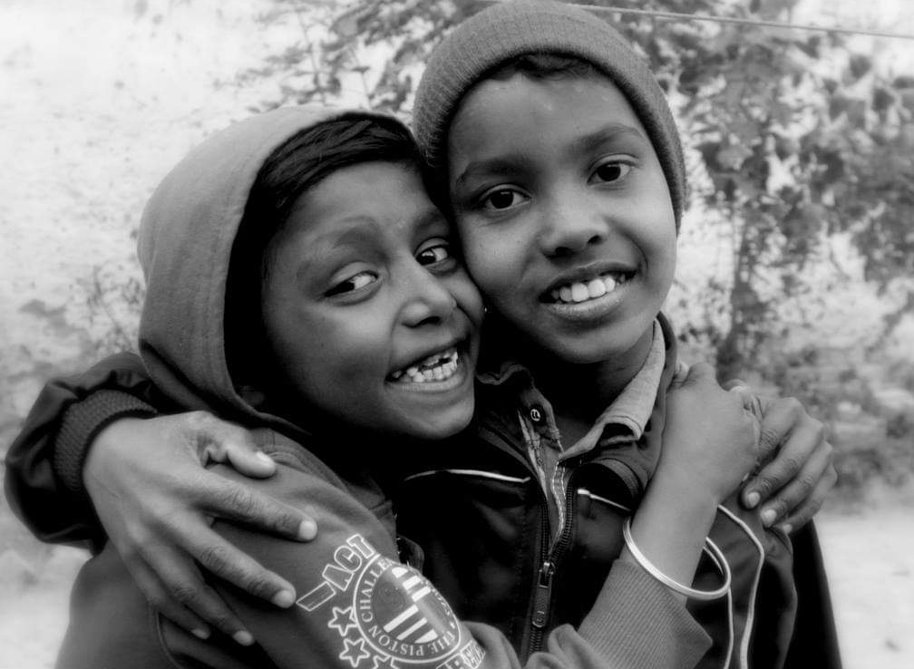

ANNUAL REPORT
2021–22

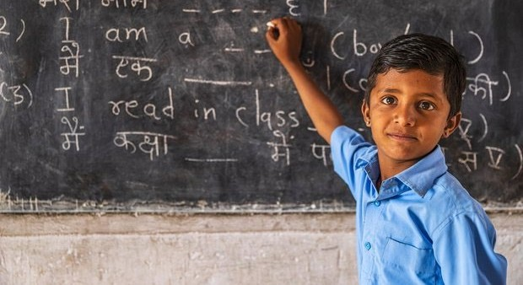

Image Source: Google

Prayas JAC Society
Registered Office; 59, Tughlaqabad Institutional Area New Delhi-110062
www.prayaschildren.org

CONTENTS

ABOUT PRAYAS JAC SOCIETY: 02
VISION AND MISSION: 03
GOVERNANCE: 04-08
PRAYAS CHILDLINE-1098: 09-12
MAP-16 Project: 13-14
ACCESS TO JUSTICE PROJECT: 19-20
CHILDREN’s HOPE: 21-22
NAYA PRAYAS: 23
ADOPTIONSCENTRUM: 24-26
CENTRE OF EXCELLENCE: 27-28
PAHAL PROJECT: 29-30
MAKING TOMMORROW: 31
PRAYAS SKILL DEVELOPMENT PROJECT: 32-37
PRAYAS HOMELESS PROJECT: 38-40
PRAYAS HEALTH PROJECT: 41-42
British Asian Trust Project: 43
FINANCIALS: 44-45
PARTNERS: 46

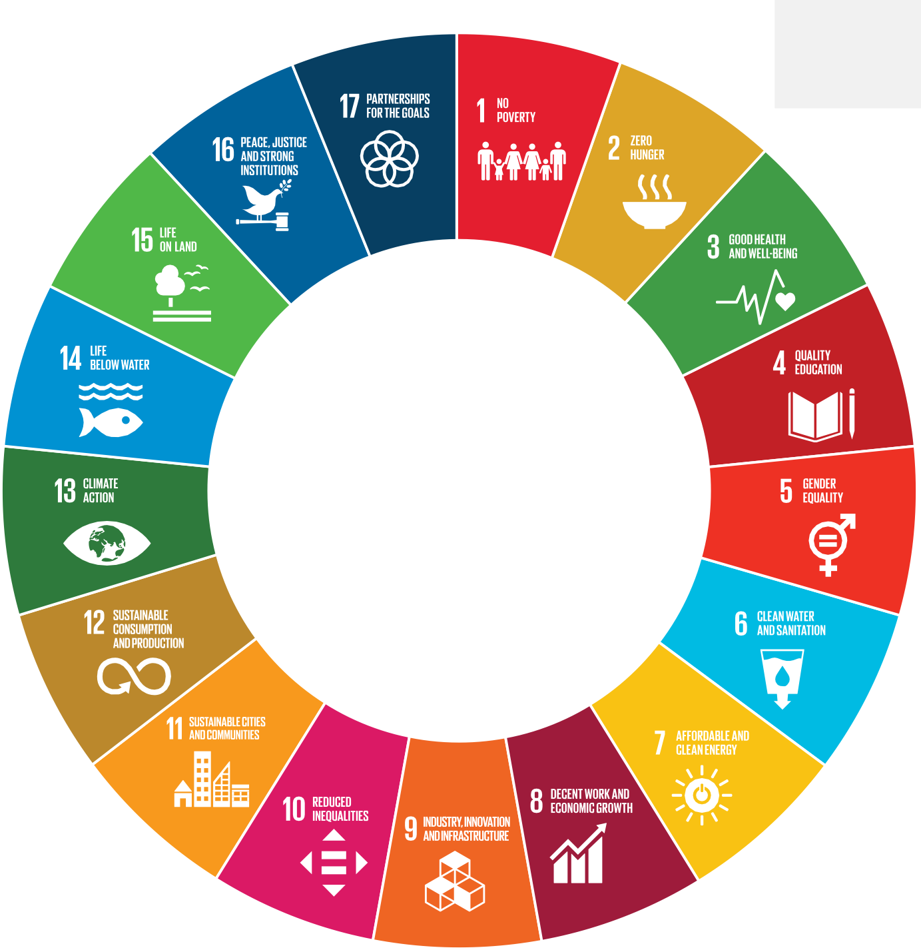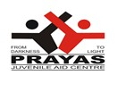Prayas JAC Society thematic areas are aligned to Sustainable Development Goals (SDGs), aimed to create cohesive and sustainable model for community

Prayas Thematic Areas
Juvenile Justice, Child Protection, Child Abuse, Trafficking of Children and Women, Child Labour & Bonded Labour, Street and Working Children, Child Marriage, Education & Life Skills, Disaster and Risk Management, Health & Nutrition, Sanitation, Voluntary & Social Sector: Role of NGOs/CSOs/CBOs, Livelihood and Social Entrepreneurship, Homelessness, Institutional Vs Non- Institutional Care, Action – based Studies & Follow up, Advocacy & Role of Media
– Print, Electronic, Social

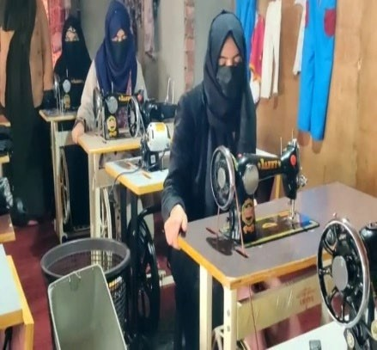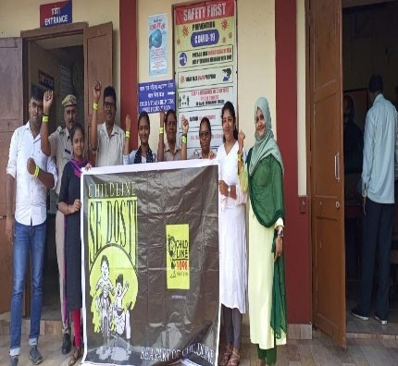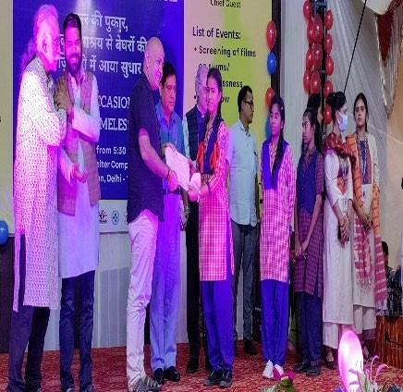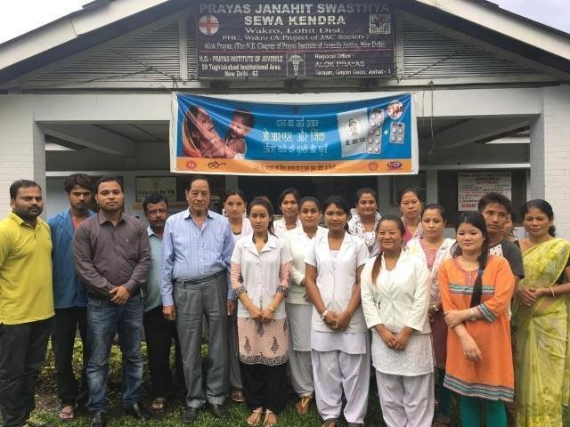
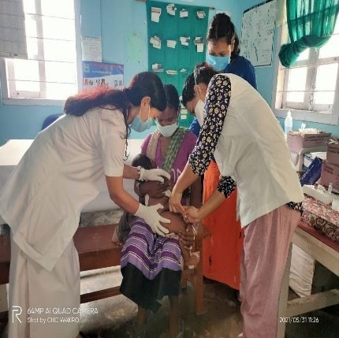
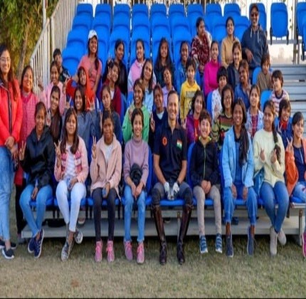
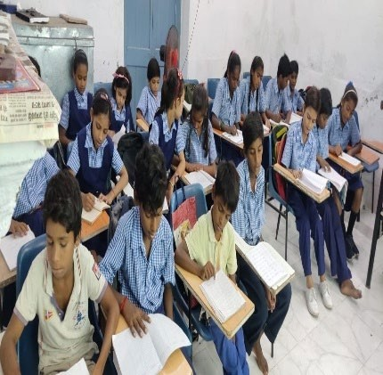
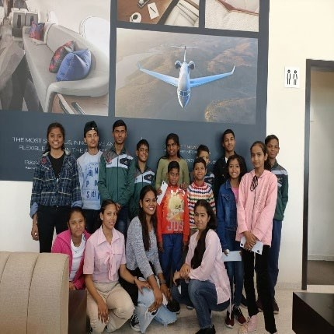

2

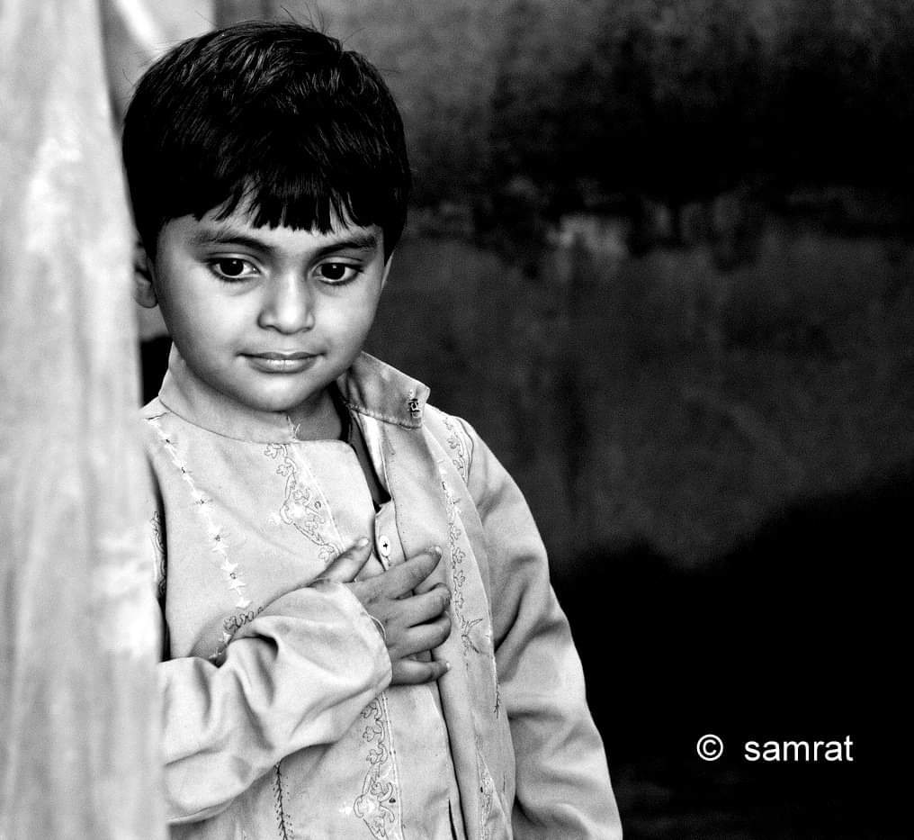
About Prayas JAC SOCIETY
Starting with 25 Children in 1988, after a massive fire broke out in Jahangirpuri (North Western part of Delhi), which destroyed many lives and separated children from their parents. In its journey of thirty four years became a national level, non-profit, child centric organization having presence in 10 States/UT’s namely Delhi, Assam, Bihar, Arunachal Pradesh, Gujarat, Haryana, Rajasthan, Andaman & Nicobar Islands, Jharkhand and Kashmir
Mostly carrying out its direct intervention for the children, youth, women and homeless and others in need of care and protection through its 38 Homes/Shelters for Children and Adults, 06 Helplines for the distressed children, women helplines, crisis intervention centre besides other programs concerning disaster, education, nutrition, vocational training, health services, vocational training, health services, life skill program, legal services, aimed to create nurturing space for the marginalized, vulnerable, destitute, and deprived children, youth and women coupled with creation of solid foundation for sustainable community ownership.
In articulating its vision of progress, development and inclusion, Prayas has affirmed its commitment to fulfilling children’s right and empowerment of marginalized segment of the society. Recognizing the potential in every needy individual, Prayas JAC Society believes in empowering the masses, strengthening them to build future for themselves and for their communities.

VISION AND MISSION


Vision
Mission
MISSION
VISION
Prayas with its dedicate and
compassionate team meeting the best nationally and internationally accepted norms and standards in social sectors, as a front in eradicating all forms of
discrimination providing
skills, healthcare,
education,
shelters,
transformational
empowerment marginalized & adhering to the
practices.
and socio-economic
to
the
vulnerable
deprived
groups
just fair and needy
Prayas mission is to protect the
rights and fulfil the basic needs of the deprived,
exploited, and
marginalized,
abused children,
women, and youth in order to
empower them through integrated & holistic services for their self- sustainable existence with dignity. We also create safe, secure, social environment and provide homes and shelters for vulnerable population with love, care, and
affection

THEORY OF CHANGE
If disadvantaged and marginalized children, youth, and women be empowered with education, health, and skill development program with a holistic approach; it will unleash dynamic forced in them to become the agent of social change in the
SOCIETY

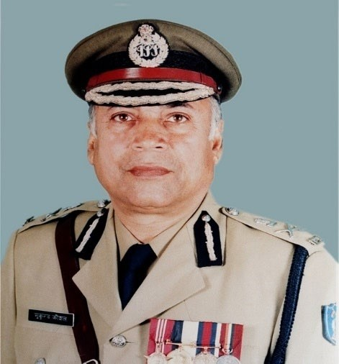

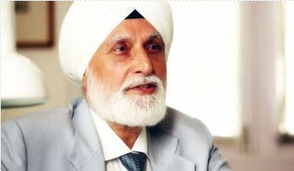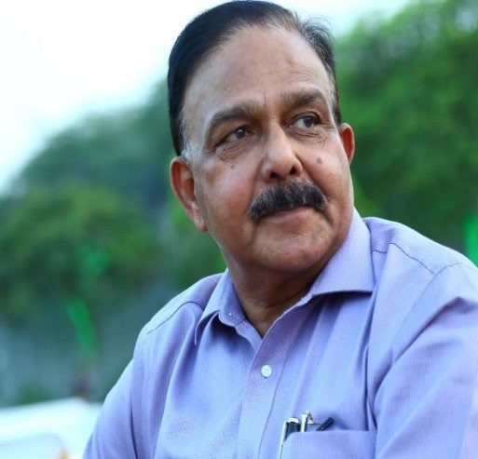
Mr. Mukund Bihari Kaushal, President Former Commissioner, Delhi Police Former Secretary, Internal Security MHA

Dr Kalyan Sachdev, Vice President

GOVERNING BODY OF PRAYAS (GOVERNANCE)
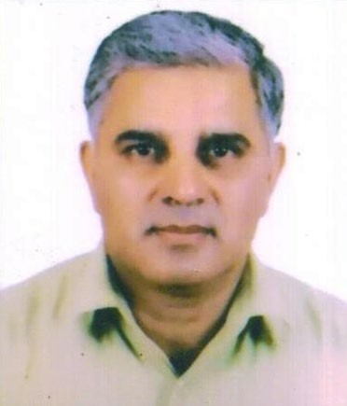
Chairman, Piravat Hospital

..

Mr. Jasvir Malik, Joint Secretary.
Former ACP, Delhi Police
Mr. Amod Kanth, General Secretary Former DGP, Arunachal Pradesh & Goa Jt. Coordinator Standing Committee NITI Aayog & CSOs
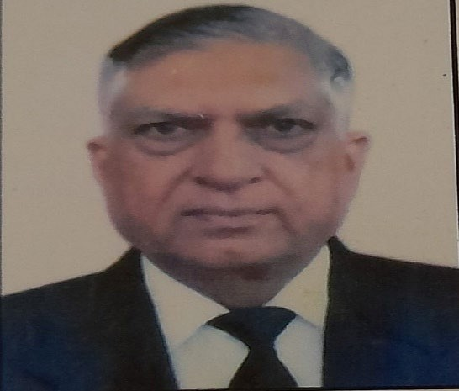
Advocate Subhash Narang, Treasurer

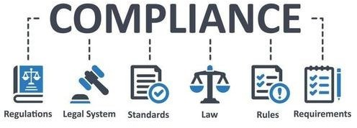

Mr. Jasbir Malik, Joint Secret Former ACP, Delhi Police
Advocate Subhash Narang, Treasurer

COMPLIANCE REPORT 2021-22
ary

Major Objectives of the Society

- To undertake various welfare programs for identification, protection, care, development, and rehabilitation of neglected and disadvantaged children, youth, and women
- To promote and organize educational and alternative education programs for these groups and to design, develop and conduct various related training and orientation activities
- To run life skills and vocational training programs and to create livelihood, income generating and other productive and economic empowerment activities for their dignified placement and rehabilitation.
- To provide basic health, nutritional and medical services and to organize various other related activities and to render psychological support, counseling coupled with creative life amongst children, youth and women
- To create Homes & Shelters for the deprived, destitute, marginalized, trafficked, working, vulnerable children, women & homeless including those affected by crisis and disasters, particularly those in the need of care and protection, welfare and developmental ensuring them holistic development.
- To create and run activities and programs for the environmental improvement, basic hygiene, and sanitation to help the disadvantaged group and to organize them to bring about changes in their lives and surroundings.

Registration Details
Registration Number: S-20291 Dated 29th August, 1989. Registration No. u/s 12 A: AAATP0449EE20214 dated 28/05/21 valid till 3st March 2026 CSR Registration Number 00001803, NITI Aayog Darpan Portal DL/2017/0166 Exempted under Section 80 G (5) (vi) Of Income Tax Act, 1961. Registration. No. AAATP0449EF20214 dated 28/05/21 valid till 31st March 2026. Registered under section 6(1) of the Foreign Contribution (Regulation) Act, vide registration number is 231650681 valid till 31st March, 2023

GOVERNANCE

Details of Governing Body Members
SL. No | Name | Age | Gender | Position | Occupation | Area of  Competency | Meetings  Attended
1 | Mr. M.B.  Kaushal | 80 | Male | President | Civil Servant | Policy, Strategic Management  & Operations | 2/2
2 | Dr. Kalyan Sachdev | 80 | Male | Vice President | Health Services | Medical, Strategic Management  & Operations | 2/2
3 | Mr. Amod Kanth | 75 | Male | Gen. Secretary | Civil Servant | Policy, Strategic Management  & Operations | 2/2
4 | Mr. Jasbir Malik | 65 | Male | Joint Secretary | Police Service | Policy, Strategic Management & Operations and Fund  Raising | 2/2
5 | Adv Subhash Narang | 74 | Male | Treasurer | Legal Service | Policy, Strategic Management  & Operations | 2/2
6 | Prof. (Dr) Aruna  Bhardwaj | 80 | Female | Member | Academician | Policy  Advocacy | ½
7 | Mr. N.K. Singhal | 86 | Male | Member | Civil Servant | Policy  Advocacy | ½
8 | Mr. Anoop Chadha | 71 | Male | Member | Entrepreneur | Policy, Strategic Management  & Operations | -
9 | Prof Kanwar Pawar | 70 | Male | Member | Academician | Policy, Strategic Management  & Operations | 2/2
10 | Mr. Kumar Rohit | 57 | Male | Associate Member | Service | Policy, Strategic Management  & Operations | 2/2
11 | Dr. Supriyo Mukherjee | 57 | Male | Member | Health Services | Policy, Strategic Management  & Operations | 2/2
12 | Mr. Vibhu Talwar | 49 | Male | Member | Health Services | Strategic  Management & Operations | ½

13 | Mr. Prince Solanki | 46 | Male | Member | Educationist | Operations and Fund  Raising | 2/2
14 | Ms. Vandana Kumari | 70 | Female | Member | Civil Servant | Policy, Strategic Management  & Operations | 2/2
15 | Mr. H.N Sahay | 75 | Male | Member | Corporate Professional | Policy, Strategic Management  & Operations | 2/2
16 | Mr. Amitabh Srivastava | 76 | Male | Member | Journalist | Policy, Strategic Management  & Operations | 2/2
17 | Prof (Dr) Saurabh Anand | 46 | Male | Member | Academician | Policy, Strategic Management  & Operations | 2/2
18 | Mr. Naveen Verma | 63 | Male | Member | Civil Servant | Policy, Strategic Management  & Operations | 2/2
19 | Ms. Indu Rani Singh | 52 | Female | Officiating Member | Social Worker | Policy, Strategic Management  & Operations | 2/2
20 | Mr. Pawan Jha | 54 | Male | Officiating Member | Social Worker | Policy, Strategic Management  & Operations | 2/2
21 | Mr Vishwajeet Ghoshal | 47 | Male | Officiating Member | Social Worker | Policy, Strategic Management  & Operations | 2/2

Constitution of Committees
Mr. Amod Kanth, General Secretary in its order dated 24th June, 2022 constituted the following committees, namely, Resource and Finance Committee, Prayas Institute of Economic Empowerment/Jan Shikshan Sansthan/ Sanchay Prayas Savlamban Sanstha aimed to uphold the values and objectives of the organization, development of thematic areas, skill development programs, resource generation etc.

Resource & Finance Committee:
Mr. Anoop Chadha, Governing Body Member- Chairperson, Mr. Subhash Narang-Treasurer Prayas JAC Society, Mr. Jasvir Singh, Joint Secretary & Governing Body – Member, Mr. Prince Solanki-Member, Mr. Vibhu Talwar-GB Member, Mr. Vishwajeet Ghoshal-Director Projects,

Mr. Pawan K. Jha, Finance Controller – Coordinator, Mr. Preetam Rakesh, Finance Manager and Mr. Puneet Varma, Manager (Resource)

PIEE/ JSS/ SPSS Skill Development & Livelihood Committee:
Ms. Vandana Jena-Chairperson, Mr. H.N. Sahay, Governing Body Member, Ms. Indu Rani Singh, Executive Director, Ms. Sadhna Srivastava, Director – JSS Delhi, Mr. Amardeep Sinha, Director – JSS Samastipur, Co-opted Members- all Directors JSSs, Mr. Manoj Sinha, Addl. Director, Prayas- Coordinator

Prayas Institute of Juvenile Justice
Mr.Amod K. Kanth- GS Prayas Chairperson, Prof. Aruna Bhardwaj-GB Member, Mr. Kumar Rohit-GB Member, Ms. Indu Rani Singh, Executive Director, Ms. Jeebanjyoti Mohanti- Add. Director IJJ-Office, Mr. Manoj Kumar Sinha- Add. Director PIEE, Mr. Jitendra K. Singh- Coordinator Operations AJP & State coordinator, Bihar, Ms. Ambreen Fatima, Asst. Coordinator Operations AJP, Ms. Deepshikha Singh, Sr. Manager IJJ & Superintendent Prayas Children Home for Girls, Ms. Smriti Das, Sr. Manager Media, IEC Documentation.

The Governing Body Meeting held on 24th May 2021 in Financial Year 2021-2022. In this meeting, they have transacted the business of the society. It ensures the organization compliance with laws and regulations and ratification of policies and protocols governing various laws and regulation including approving the Audited Financial Accounts and Annual Report of the previous financial year and approving the programs and budget for the year 2022-23. The Governing Body Meeting also passed resolution to set up Jan Shikshan Sansthan (JSS) Ramgarh (Jharkhand), JSS Jamui (Bihar) and JSS South Andaman (Andaman & Nicobar Islands) as per the direction of the Ministry of Skill Development and Entrepreneurship (MSDE), GoI.
Minutes of Governing Body Meetings are documented and circulated to all members within seven days of the meeting held on

Accountability and Transparency
Head of the Organization (including honorarium)- Rs.0.00 NIL
(Mr. Amod Kanth is Founder General Secretary of Prayas JAC Society who holds an honorary position)
Highest paid full time regular staff Rs 12.00 lakhs per annum
Lowest paid staff (Full Time basis) Rs 1.20 Lakhs per annum
Fees for Statutory Audit Rs 2.58 Lakhs per annum
The Governing Body Members are working on pro-bono basis. No Sitting Fees for attending Governing Body Meetings has ever been paid. The following reimbursements have been made to Governing Body Members: Travelling
Expenses (to attend Governing Body Meetings) - NIL. Staff Details
The Total Staff of Prayas is 798. Men-413 and Wome Salary Details
n-385
Salary Status of Employees as on 31st March | 2022
Between 5000-10,000 | 464
Between 10,000-15,000 | 135
Between 16,000-25,000 | 148
Between 26,000- 40,000 | 33
Between 41,000- 50,000 | 7
Between 51,000- 70,000 | 8
Between 71,000- 1,00,000 | 3

8

“Chhayaam anyasa Kurvanthi thishtanthi svayam aathape Phalanthi cha parartheshu na Swartheshu mahadhrumah” Trees stand in the scorching sun Yet provide shade for others They bear fruits
Not for themselves, but for Others

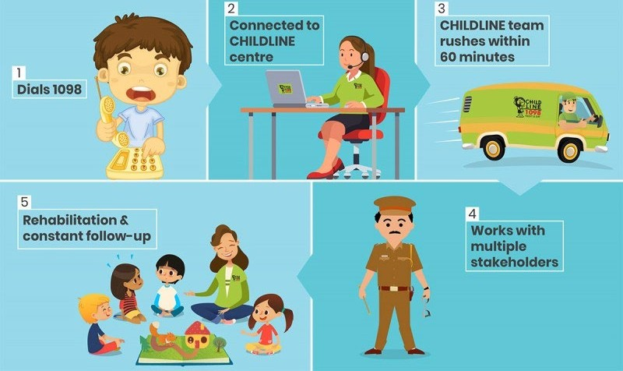CHILDLINE 1098, which was initially started as Field Action Project of the Department of Family and Child Welfare, Tata Institute of Social Sciences, Mumbai on 20th June 1996 by Prof. Jeroo Billimoria. The CHILDLINE 1098 service, developed and managed by CIF, is a 24x7, emergency, free phone outreach service linking children in need of care and protection to relevant organisations run by Government departments and civil society organisations for long-term care, protection, and rehabilitation. Any child or adult calling on behalf of a child is assured of assistance from a trained team capacitated to reach the child within an hour of having received a call on 1098 with its presence in form of ‘emergency intervention units available in 602+ districts, 144+railway stations and 11+ Bus Terminals have CHILD HELP DESKS through a well-integrated network of 1074 partner organizations.
PRAYAS CHILDLINE 1098
Image Source: CHILDLINE INDIA FOUNDATION
Delhi CHILDLINE started as a collaborative Project on 2nd October 1998. Although, it was inaugurated at Prayas Children’s Home by the then Union Minister for Social Justice and Empowerment, Ms. Maneka Gandhi. A meeting was organized in the Ministry under the Chairmanship of the then joint secretary, Mr. Anand Bordia, to orient the Delhi NGO’s about CHILDLINE Project. Several NGOs had participated in the meeting but finally five organizations Prayas, Don Bosco Ashalayam, Delhi Brotherhood Society, Salaam Baalak Trust and Butterflies were selected to run the project in Delhi.
Like Delhi, Prayas CHILDLINE started operation in Andaman & Nicobar Island with its missionary zeal from Jan 5, 2005 when it was practically wiped out by Tsunami. It focuses on two major areas to start with Car Nicobar and Campbell Bay. The Prayas CHILDLINE 1098 at New Delhi Railway Station was inaugurated by then Railway Minister Mr. Suresh Prabhu along with the then Union Minister of Women & Child Development Ms. Maneka Gandhi.

ANALYSIS OF CALLS:
In addition to being the first respondents to children in need of care and protection by reaching out to the distress children, it also plays a critical role in shaping and strengthening the existing National Child Protection Schemes. In 2021-22, Prayas CHILDLINE 1098 in Delhi (Jahangirpuri, New Delhi Railway Station, Poothkhurd-Bawana), Bihar (Samastipur, Raxual) and Andaman & Nicobar Islands (Port Blair, Little Andaman,) Every case received by CHILDLINE 1098 is unique. Some are resolved within a day others may require follow up for months. CHILDLINE received a number of calls from worried parents, sensitive, adults, the community, well-wishers and the distraught children of India.
The below-mentioned interventions/cases are a mere drop in the ocean of the work done by the CHILDLINE team of Prayas
Categories | Delhi | Bihar | Andaman & Nicobar Islands
Intervention
Medical | 23 | 1 | 18
Shelter | 127 | 2 | 109
Restoration | 4 | 0 | 86
Protection from Abuse | 87 | 24 | 116
Child in Conflict with Law | 4 | 0 | 0
Sponsorship | 0 | 0 | 2
Missing | 177 | 13 | 6
COVID-19 | 73 | 0 | 15
Poshan Maah | 114 | 0 | 0
Emotional Support  & Guidance | 65 | 0 | 27
Other Intervention | 3 | 0 | 0
Information and Referral  to Services | 18 | 0 | 3
Intervention Follow Up | 13 | 3 | 4
Silent/Confidence Buildin | 19 | 0 | 8
Non-Intervention Call
Awareness Building | 65 | 0 | 0
Technical Connected  Problems | 0 | 0 | 0
Any Other | 131 | 171 | 119
Total (1)+(2) | 953 | 214 | 513

CHILD PROTECTION CONCERNS MAP
CHILDLINE India Foundation had prepared the ‘Child Vulnerability Map’ - a district-wise map depicting problems faced by children across the country, which had been launched by the Ministry of Women and Child Development, as part of the National Plan of Action for Children in January
2019. At the time, it covered 409 of a total of 678 districts in the country, and mapped key child protection concerns including Child Marriage, Child Trafficking, Missing and Runaway Children, Child Labour, Child Abuse, etc. This was envisioned as a planning tool which would enable district
officials to match services designed for children with the issues prevalent in their respective regions. It now depicts the district-wise child protection concerns across all districts in the country where CHILDLINE 1098 services are operational (598 districts as of 31st March, 2021).

STORIES OF INTERVENTION
(The Identities of Children have been kept confidential in accordance with the Juvenile Justice (Care & Protection of Children) Act, 2015)

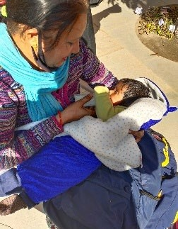
Komal, aged 3 Month Abandoned Child placed at State Adoption Agency by Child Welfare Committee, Alipore
Prayas CHILDLINE 1098 Poothkhurd Bawana received call from 1098 on 25th January 2022, about a 3-month-old girl child being left abandoned near bushes at Narela border by her mother only as she was finding difficult to raise her alone in absence of any source of income from her family. Her husband was paralyzed and on bed from more than 8 month. The Grandmother of the child also expressed her helplessness that her advanced age coupled with her ailing condition; she could not take care of her granddaughter. The CHILDLINE TEAM contacted Child Welfare Committee Alipore and submitted details of their findings followed by the directions of the CWC to produce child, her mother and
grandmother on 27th January 2021 before the Bench. Following the direction of the CWC, the team brought child, her
mother and grandmother first at ‘Shahbad Dairy Police Station for Daily Dairy Entry followed by their production before the bench of CWC for its appropriate direction. The Child was taken to ‘Raja Harishchandra Hospital’ for immediate medical examination of the child and placed Komal at Holy Cross Orphan Home.

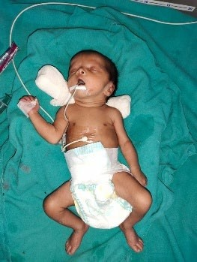
- Fourteen Day Child left abandoned at the mercy of Almighty On 31st October, 2021, Prayas CHILDLINE Team at Poothkhurd Bawana received call from women helpline about 14-day old girl child near bushes at Narela. Though, her treatment is going on at ‘Baba Sahab Bhim Rao Ambedkar Hospital’
The CHILDLINE 1098 is being requested to take charge of the child by following the provisions of the Juvenile Justice (Care and Protection of Children) Act, 2015 by producing the child before the bench of ‘Child Welfare Committee’ to set her legally free for ADOPTION. The CHILDLINE Team took entire responsibility of the Child and also deputed one Team Member at the Hospital as attendant for 5 days before producing the child before the
bench. On 25th October 2021, the child was declared set free for legal adoption and placed the child at ‘Multan Nagar Ashram’

Child Abuse
Name: M. Pandi Meena (07 Years) Female Case ID: 508 723

On 30th July 2021 CHILDLINE 1098 received a call from P.S. Pahargaon regarding a case of the minor child. The child Pandi Meena stays with her parents and two brothers in Andal Basthi at New Pahargaon and is a student of Govt. Senior Secondary School Prothrapur and is studying in class 5th
Upon intervention the child, Meena told that around 10 to 15 days back the child and her friend Swetha went with the child’s father Muniaswamy to a jungle behind Prothrapur School to get jackfruit. Upon reaching there the child’s father Muniaswamy asked the child to go and get some water for him. While Swetha stayed back, Meena came to fetch water. Upon reaching back she saw her father sitting down and Swetha standing with her bottom half removed, and her father’s mouth at Swetha’s bottom. Upon seeing Meena, Swetha pulled her pant up. Then, after a while the father asked Meena to go home and get sack to carry jackfruit. While Meena came back after getting the sack, her father rushed to climb the tree.
The child Meena further told that her father had molested her twice at home during night when her mother was out for her night shift.
Assistance Provided: Child Welfare Committee placed the child at Children Home.

GLIMPSES

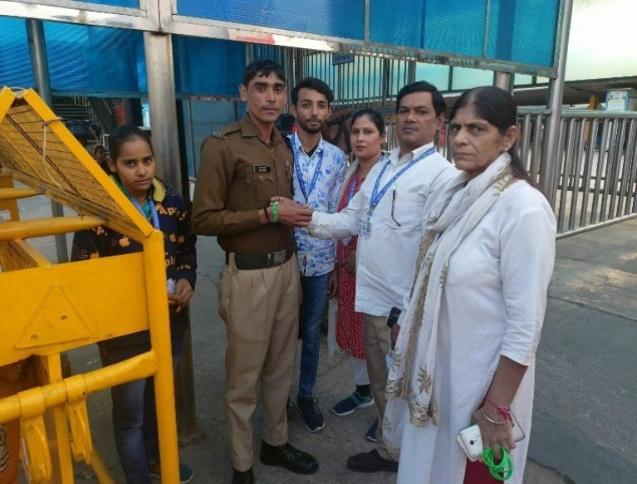

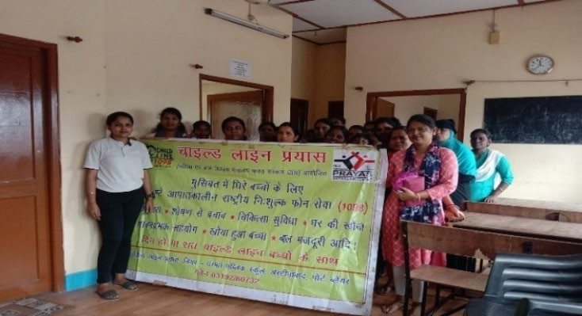
Awareness Week
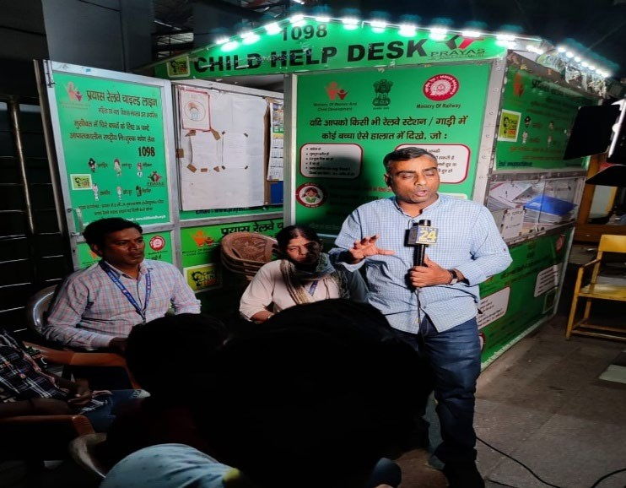
Media Briefing on rescue of Children at New Delhi Railway Station
CHILDLINE SE DOSTI WEEK
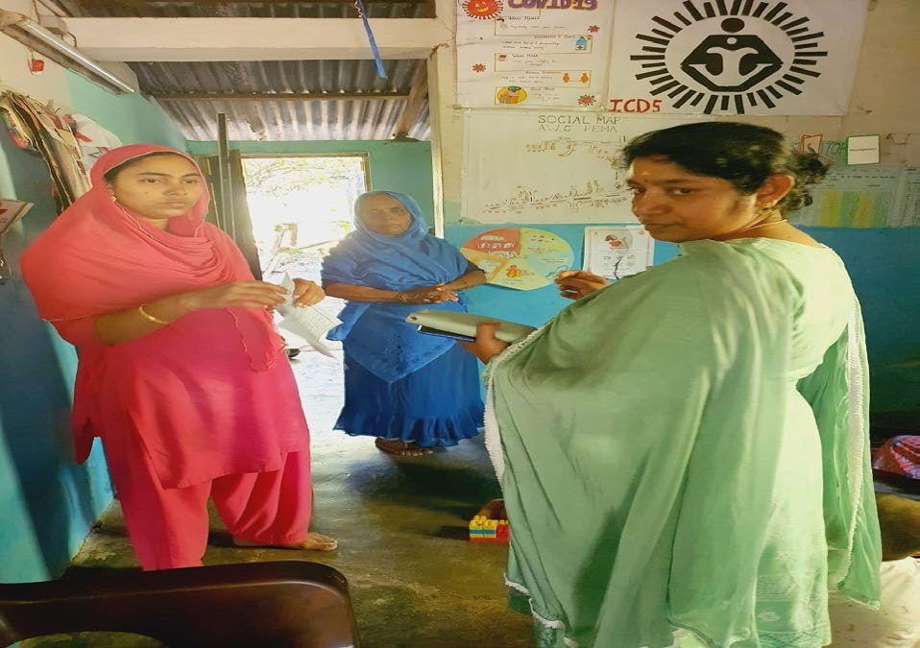
Awareness Program at Andaman & Nicobar Island

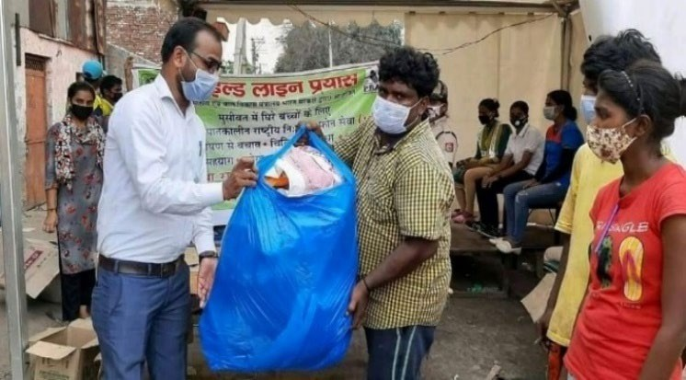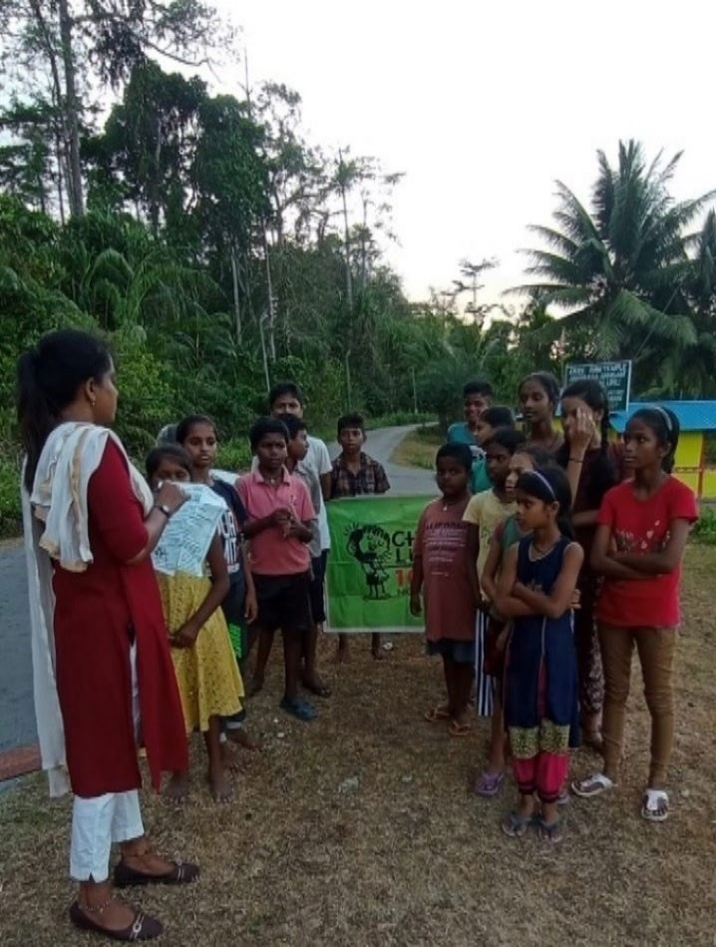
Ration Distribution during COVID by Northwest CHILDLINE CHILDLINE AWARENEE at Little Andaman
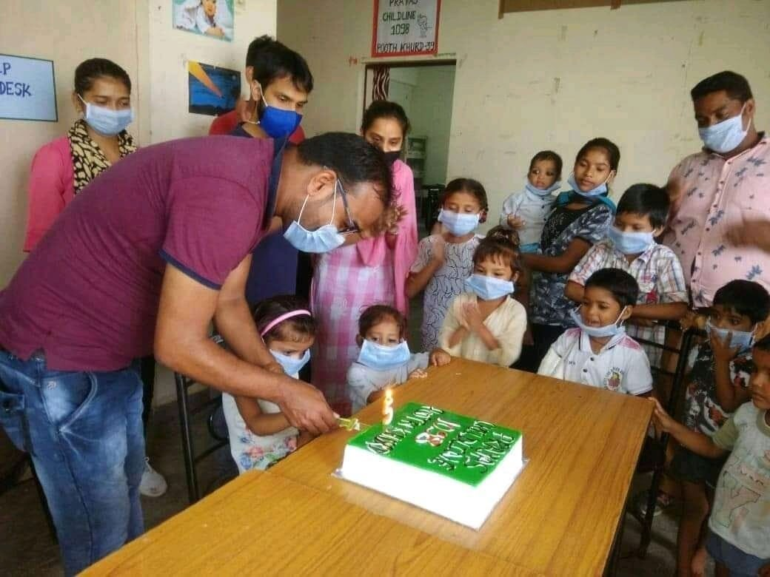
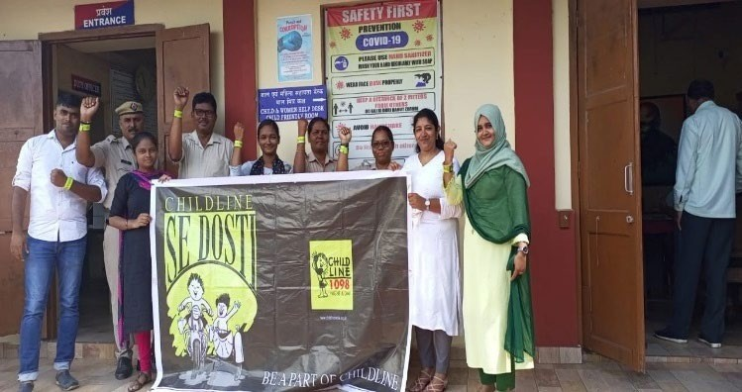
Birthday Celebration of CHILDLINE Awareness Camp at Andaman & Nicobar Islands

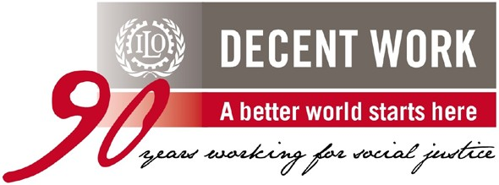MAP-16 PROJECT

MEASUREMENT, AWARENESS RAISING AND POLICY ENGAGEMENT (MAP 16) TO ACCELERATE ACTION CHILD LABOUR

The enactment of the Child Labour Amendment (Prohibition 2009 paved the way for ratification of the ILO’s two core conventions - Convention No. 138 on Minimum Age for Admission to Employment and No. 182 on the Worst Forms of Child Labour. These ratifications have helped expand the protection coverage of the world’s children by 20 percent. It also has prepared India for meeting the global Sustainable Development Goals (SDGs), in particular the Goal 8.7 pertaining to child labour.

The main objective of MAP 16 project is to help build and apply critical knowledge needed to inform policy choices to combat child labour and forced labour and to support measures to address these challenges in select states/sectors in India. Prayas partnered with ILO to work in two districts of Bihar, namely, Jamui and Nawada, aimed to eliminate child labour through services/schemes of the government in the field of education, health, skill development etc.

The major activities conducted by Prayas under MAP 16 project were as follows:

  - District Level Consultative Workshops on convergence of child labour in Bihar (Nawada and Jamui Districts) and also to work in tandem with the Labour Resource Department, Bihar on project activities.

  - District Level Consultative Workshops on survey tools for child labour in Jamui and Nawada Districts of Bihar based on Child Labour Tracking System, (CLTS)

  - Convergence of scheme, namely, Samagra Siksha, Poshan, Jan Dhan Yojana, National Social Assistance Program, Livelihood-MGNREGA, Skill PMKVY and Ujjawala to be taken into consideration for outreach programs through community mobilizers to be identified in the selected blocks of Jamui (Blocks; Barhat, Jamui Sadar, Jhaja) and Nawada (Hisua, Sirdalla/Roh and Nawada Sadar) at the District Level Meeting

  - To engage ‘community mobilizers/volunteers’ preferably in the age group of 18-24 years for six selected blocks to enhance accesses and utilization of government schemes to target vulnerable household.

IMPACT;
District Covered: Jamui and Nawada, Blocks Covered: Barhat, Jamui Sadar, Jhaja, Hisua, Sirdalla/Roh and Nawada Sadar

SUPPORTED BY: International Labour Organization

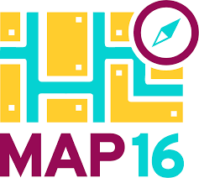
GLIMPSES OF MAP 16 PROJECT

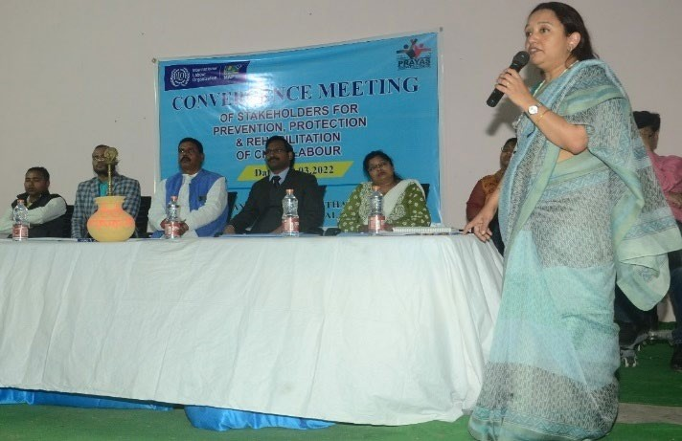
Ms. Bansari Nag, ILO at Convergence Meeting

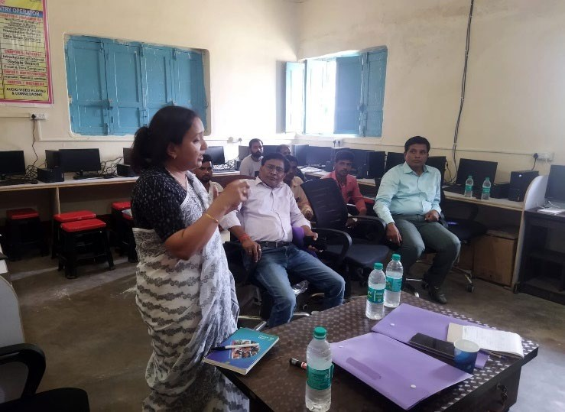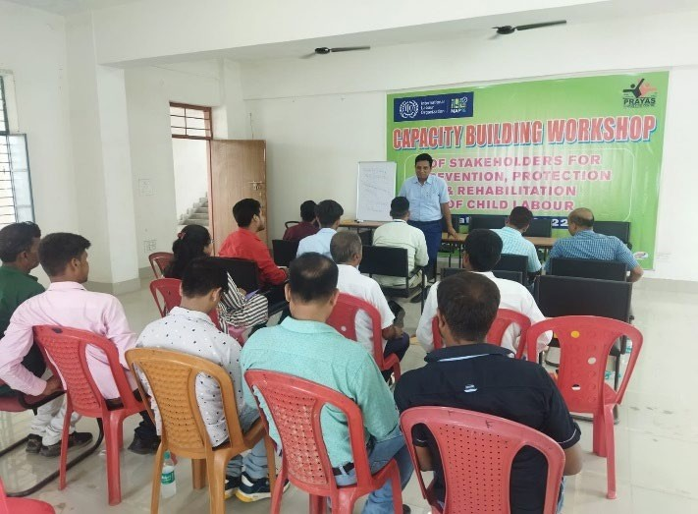
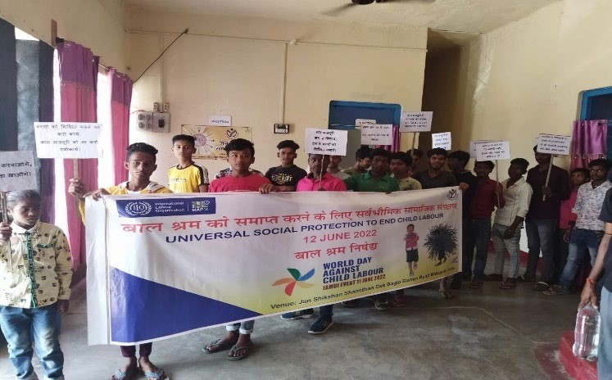
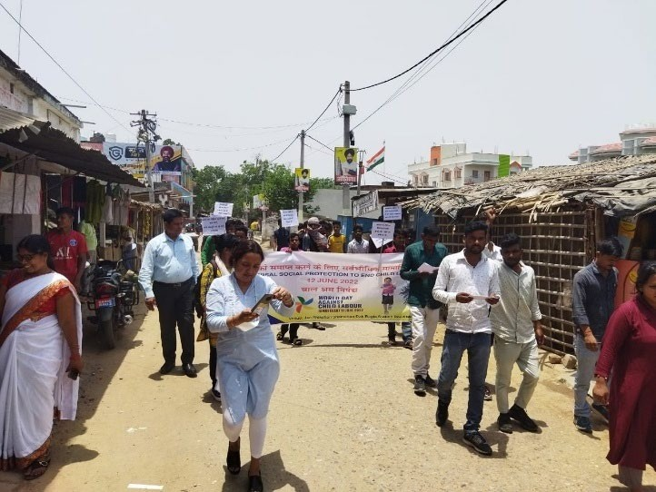
Review Meeting Capacity Building Program
Awareness Program Awareness Program

IMPACT;

Families
Reached
168
Villages
Covered
64
Schemes
Connected
66

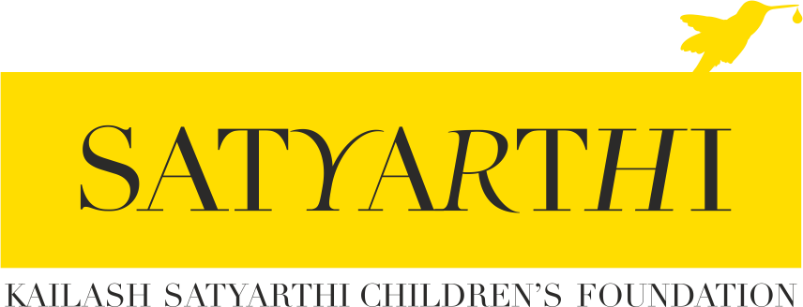
ACCESS TO JUSTICE PROJECT

The Access to Justice Project was brought into existence by Kailash Satyarthi Children’s Foundation (KSCF) US which brought together three critically important organizations – Bachpan Bachao Andolan, Prayas Juvenile Aid Centre and Shakti Vahini along with several other grassroots-level partners
to work on three thematic areas – child sexual abuse, child trafficking and child labour. The focus of this project is legal intervention in cases of child sexual abuse, child trafficking and child labour to ensure end to end justice to all child victims of these offences.

Project Description:
The Access to Justice Project aims at creating a safety net and ensure access to speedy justice for children who are victims of sexual abuse, child labour, and trafficking. Through this project, the organization would enhance the rate of compensation and conviction in cases of child sexual abuse. We would also encourage the community to report cases of child sexual abuse as thousands of cases have been found to be unreported. The organization aims to minimize child labour and child trafficking through awareness generation, raid and rescue, rehabilitation and social re- integration. The organization would ensure fine on employers in cases of child labour and aid prosecution in cases of child trafficking. The stakeholders and other network partners would be oriented through capacity building programs, awareness for prevention, and promoting legal fellows to take up the issue of child protection in court rooms for sustainability of the project.

Project Goals:
- The goal of this ambitious project is to facilitate the delivery of justice through measurable and sustainable interventions through increased registration of FIRs, preventing unsafe out-migration of children for employment, increased association of children with mainstream education and health services, achieving higher number of convictions in abovementioned cases.
- To ensure speedy investigation and trial in cases of child sexual abuse, child labour and child trafficking
- To ensure award and disbursement of compensation to victims of child sexual abuse, child labour and child trafficking
- To have an enabling environment through system change for child protection
- The project will focus on the rehabilitation of affected children in equal measure by emphasizing on elements such as compensation and livelihood generation / support.

STORIES OF INTERVENTION
Case Study-1
In a small rural town in Samastipur, a 45-year-old man would break into his neighbour’s house and rape the young 14-year-old daughter of the house. This incident occurred repeatedly over the course of 6 months. The victim was usually alone at home during the day because her father was out of town on account of being a migrant worker while her mother worked in the fields. Eventually, when the victim began showing symptoms of pregnancy, her aunt began to suspect that something was wrong and urged the victim to confide in her. The

victim then told her aunt about the repeated assaults by the neighbour and they decided to consult the local medical practitioner. When a pregnancy test taken by the victim came positive, the family was informed, and the father was called back home.

The father of the victim confronted the accused and consequently got beaten up by the family of the accused. An FIR was then registered in the matter on 3rd March, 2022. Thereafter, Prayas received information about this case from the father of the victim.

Prayas team counselled the victim and her mother. And tried to understand whether they were interested in pursuing the pregnancy or wanted to terminate it. The well-wishers of the family from the local village were of the opinion that if the child is aborted, the evidence of the case would be destroyed and so they persuaded the family to keep the

pregnancy. Some relatives equally supported the thoughts of the well-wishers but some middle men from the accused’s side were offering money to have the pregnancy illegally terminated and the accused was ready to pay any amount for this.

During the counselling of the victim, all the options were placed before her – 1) the newborn child could be put up for adoption, 2) she could keep the child and fight for the entitlements of the child, but it was also explained that keeping the child would destroy her future marital life, health, education, and other family relationships.

After multiple sessions, the victim and her family agreed for termination of pregnancy and Prayas team filed an MTP application at the Special POCSO Court. Thereafter, the court ordered the CWC to formulate a Medical Board to determine the age of the fetus and the medical health of the victim. The CWC immediately took the victim into their charge and transferred her to a children’s home in another district. And within 5 days all medical procedures were completed. The medical report was of the opinion that the termination could not be carried out at that stage as the age of the fetus was more than 26 weeks.

After assessing the medical report, the Special POCSO Court declined to order for MTP for the victim. The Prayas team then filed a writ petition at the Patna High Court seeking an order to terminate the 26+ week pregnancy of the victim. The Court ordered a medical examination of victim to be conducted by a Medical Board and for the Board to submit its opinion to the Court. As of today, the Board has submitted its opinion to the Court however a final order has yet to be passed by the High Court. The attitude of the High Court does not seem to reflect the urgency of the matter as they have taken more than 20 days to decide upon the issues raised by the father of the victim in the writ petition.

In this case, the apex court of Bihar, is non-cooperative as they have not realized the urgency of cases of child sexual abuse. Moreover, due to the anticipatory bail filed by the accused he has not been arrested despite the fact that the victim is 14 years old.

In this case we also came across an odd practice where the Special Court allowed the accused give DNA evidence before the medical team in the courtroom on a voluntary basis as prayed by the defense counsel to seek anticipatory bail.

The community is judgmental and they are blaming the family and also requesting them to get away from this matter by giving them a negative perspective about the fact that while the accused is roaming free, their daughter has been “captured” and kept in a shelter home, humiliating the action taken by the family on the persuasion of a voluntary organization.

Apart from this, “quack lawyers” are also influencing the family in a negative way by explaining illogical and irrational practices of law in terms of non-delivery of compensation in such matters, lack of evidence in the case, delay might amount to ten years ruining the entire family as they keep on preaching that courtrooms are meant for rich people.

The entire machinery, including the society, police, and judges have failed to have an environment for access to justice except we the voluntary organizations being on the forefront along with the victim to meet the ends of justice.

Case Study-2
- F.I.R No.: Mahila Thana P.S. Case No.: 13/2022 registered on 03.03.2022
- Victim: A case of Aggravated Penetrative Sexual Assault.
Brief History
  - The case was received by Prayas Team later on till then nothing concrete action has been taken. After which Prayas Legal Officer, Zeya Ismail, has filed petition for medical termination before ld. Court ADJ-VIth.

  - The Learned Court has directed to produce victim before Child Welfare Committee (CWC, Samastipur). CWC sent the victim to the Balika Grih, Begusarai and ordered Medical Superintendent, Samastipur, to constitute a Board and to submit the Medical Report at the earliest.

  - The Medical Superintendent, Samastipur submitted his opinion on 11.04.2022 and opined therein denial of termination since the pregnancy of 26 weeks and related complication might be arisen afterwards.

  - Thus, the ld. Court ADJ-VIth finally dismissed the M.T.P petition but liberty to go for Higher Court. After that Writ Petition has been filed before Hon’ble High Court, Patna, who directed to constitute a medical board consisting of Seven Experts under the Guidance of Director (AIIMS, Patna) and directed the Medical Board to submit his opinion on or before 05.05.2022.

  - Accordingly, The Medical Board has submitted his opinion in a sealed cover on 05.05.2022 for which the final order has to be made on 10.05.2022.

Institutions Failed the Victim
- Parents/Guardian and the community delayed in registering F.I.R
- Community made an effort to compromise.
- From the date of registering of FIR, wherein, it is mentioned about the pregnancy, the Investigating officer has made no effort to produce the victim before CWC.
- The so-called medical examination has been done but no submission of medical examination before the court inspite of urgency required to do so. Only after Prayas Team Interventions, Medical Examination had been done and duly submitted.
- No arrest has been made by the Investigating officer even though the accused living freely at home.

Problems
- The Parents/Guardian is in dilemma and not able to make a decision. Always change mind due to suggestions sought by parents through various local legal acumen involved.
- The Parents/Guardian concern about arrest since no arrest has been made yet even after an application has been sent to S.P., Samastipur.

Way Forward
- First and foremost, we need to build confidence among parents that we are here to submit your grievances and the main concern is about arrest and for which he wants to meet C.M. Shri. Nitish Kumar, so we can arrange in this regard to do the needful.
- Proper counselling of the parents is required.
- The Court Should be made considerably sensitive to order against wilful negligence of Investigating officer.
- The Investigation Officer should be trained to carry forward in such cases.

IMPACT (January 2022-March 2022)
FIR REGISTERED AGAINST POCSO: 47, FIR REGISTERED AGAINST CL: 07, FIR REGISTERED AGAINST CHILD TRAFFICKING-07

ACCESS TO JUSTICE Works to ensure the implementation of current policies, schemes and laws in three thematic areas-child trafficking, child marriage and child sexual abuse by-
Strengthening Policies and Institutions; Strengthening Communities and Working with victims and their families

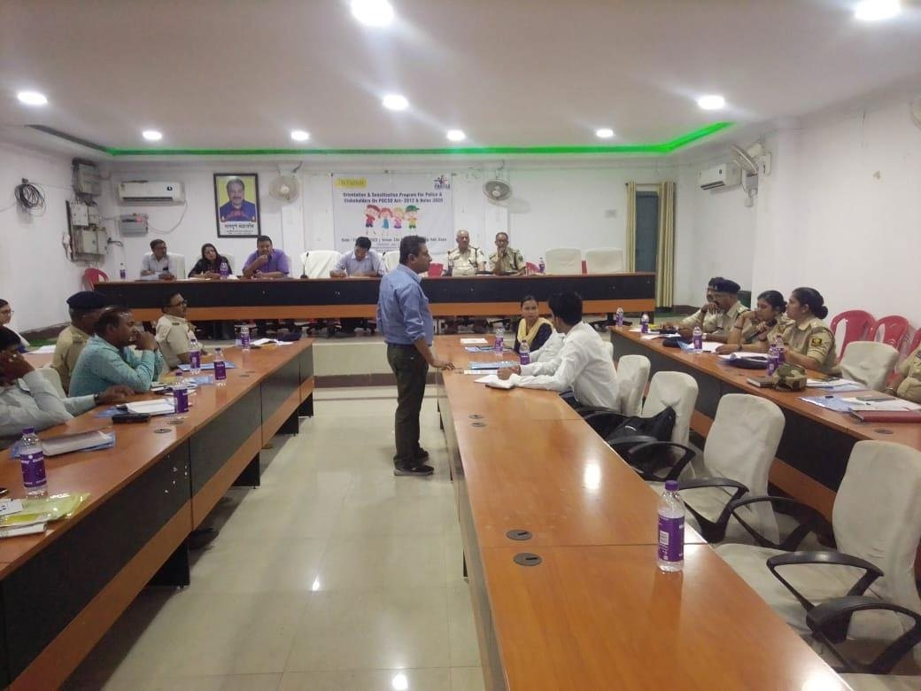
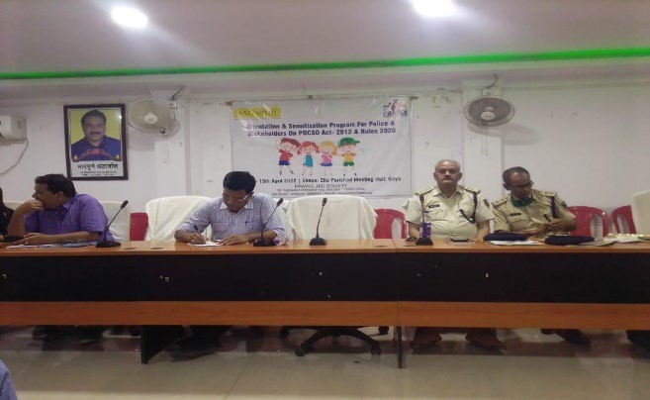
GLIMPSES
Stakeholders Meeting Stakeholders Meeting

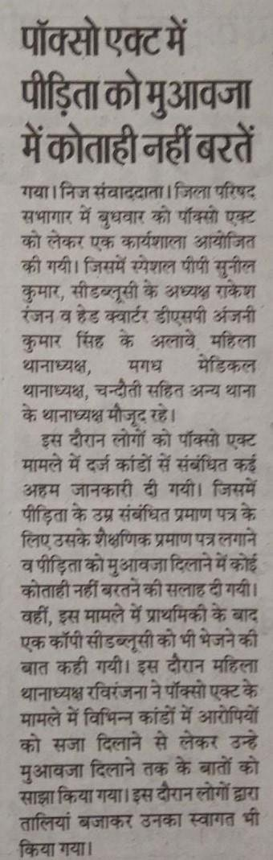
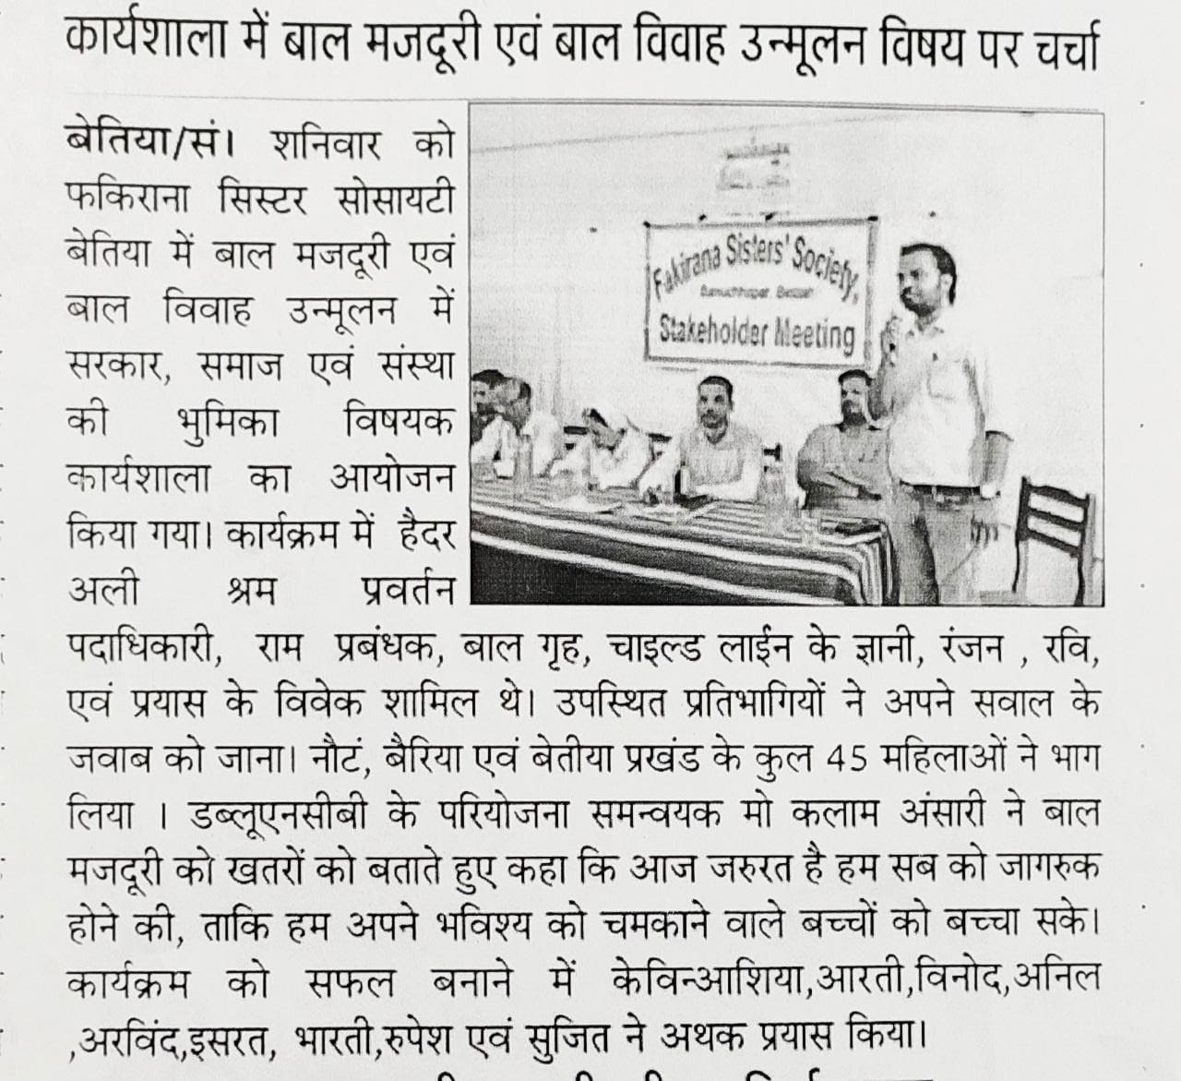

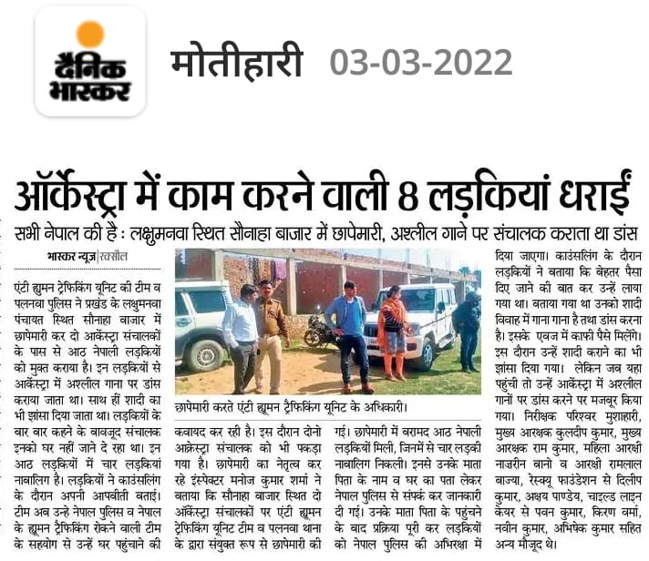

JUVENILE JUSTICE PROJECT CHILD PROTECTION
19
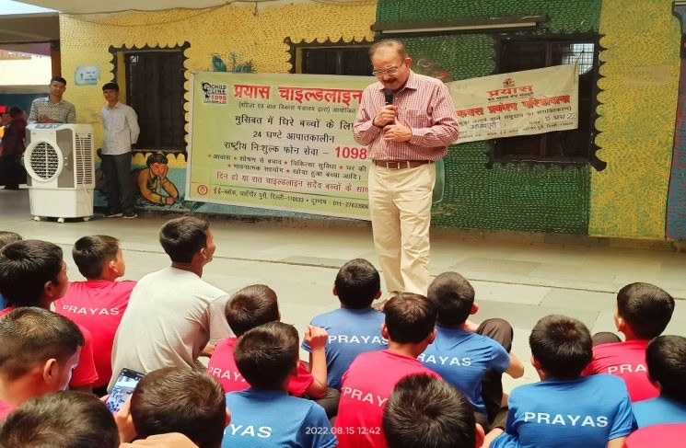
In India, about 31 million children are reported to live without parents and at least 3,77,000 children are institutionalized in more than 7500 Child Care Institutions (CCIs) impacting 1.8 million family members. It is likely that the actual number of children in need of alternative care would be far higher, considering that there is a lack of awareness in public about the systems and structures that could be reached out to when a child/family needs support (in circumstances of death, abandonment, abuse, displacement, financial instability, etc.). The
pandemic has led to increase in vulnerabilities of at-risk families, including the loss of livelihood, loss of primary caregivers of children and health concerns in the form of long COVID. With large numbers of children losing one or both parents, (as per the Lancet report, February 2022, approximately 19 lakh children lost one or both parents to COVID-19), there is a likelihood of increased number of children being separated from their families and getting placed under child care institutions or experiencing protection failures. The reasons which push these children to live isolated lives in institutions are many including poverty, misguided perceptions of CCIs providing basic needs like food, clothing, shelter, education, and safety.

To ensure effective care and protection, coupled with holistic services to every child, Prayas JAC Society is running Prayas Children Home for Boys, Jahangirpuri, Prayas Children Home for Girls, Tughlaqabad, Prayas Open Shelters at Morigate, Azadpur, Kashemere Gate in Delhi, Prayas Open Shelter at Samastipur, Purnia and Bettiah in Bihar, Railway Open Shelter at Ahmedabad, Guwahati, Danapur, and Ramgarh are categorised under Child Care Institutions CCIs, within the Juvenile Justice (Care and Protection of Children) Act, 2015 amended in 2021.

Apart from providing the routine services, namely, shelter, nutrition, education, counselling, legal services, health services and life skill program including prompt restoration and long term restorative intervention aimed at preventing re-victimization.

SERVICES IN PLACE TO ENSURE THE NEEDS OF A CHILD ARE MET

Establishing and facilitating a safe space for children in the community that has been designed for their overall empowerment and to promote life skills, career planning, effective engagement with parents etc.

Tracking the system to monitor and assess the progress of each case using a Vulnerability Assessment Tool (VAT) developed by the organisation53. Tracking and follow-up continue till the child is no longer at risk.

Mitigating vulnerabilities and meeting needs through intensive counselling sessions, home visits, and telephonic follow-ups

OUR COMPREHENSIVE CARE MODEL:

Prayas believes in promoting right based program for the children living at our various Children Home/Shelters by ensuring holistic services to every child. This is done through the provision of integrated services that includes shelter, nutrition, education, health services, legal services, vocational training, and life skill program. It also ensures effective gatekeeping and restoration of children with families or with alternative care mechanisms at the community level. It works with communities to develop safety net for children and adolescents to ensure their well-being.


Protection
Safe, Happy and Clean Spaces Codified Child Protection and Safeguarding Policy Child Protection Committees Loving and Child Friendly
Environment
Education
Mainstreaming in Schools Life Skills & Vocational Training English and Computer Skills Co-Curricular Activities


Nutrition
Menu decided by Children Four Meals a Day Hot Cooked Meals Balanced &
Nutritious Diet
HealthCare
Comprehensive Medical Check-up, De-Addiction
from Substance Abuse, Special Care for disabled Children

45 Children rescued from Child Labour by the Team of PRAYAS CHILDLINE
1098 Jahangipuri in
2021-22. INR
4,40,000 disbursed as Compensation Amount
Futures
Skill Development, Child Specific Career Plans, Vocational Training based on Interest coupled with Job Placement
Total Number of
Boys & Girls from Children Home received services: 1045
Total
Boys
Number
of
received
services: 1865

TOTAL IMPACT (DELHI, BIHAR, GUJARAT)
Total
Children
2586
RESTORATION
1647

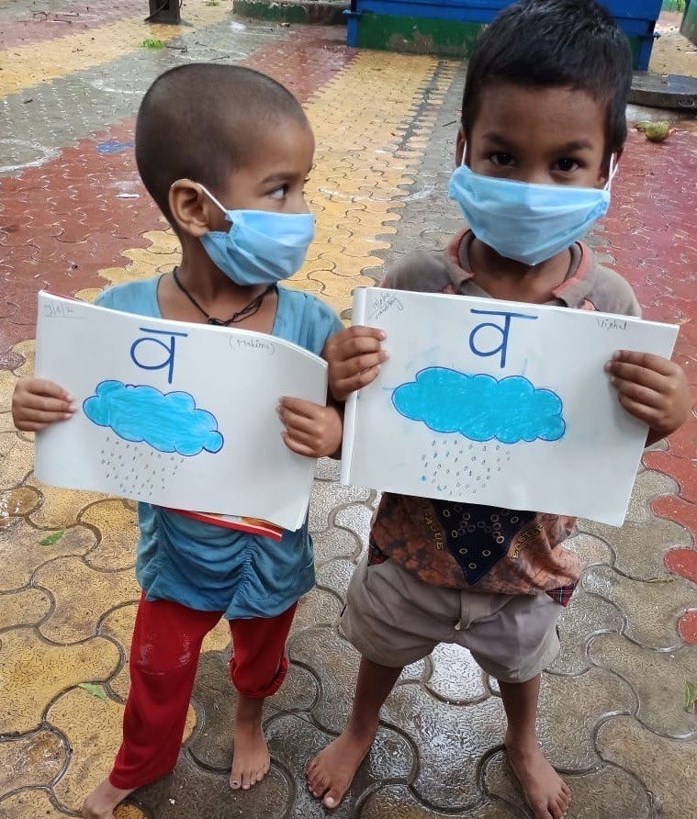
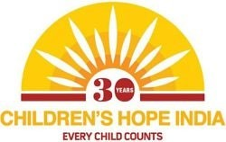
COMMUNITY BASED PROJECT

CHILDREN’S HOPE PROJECT

PC: Children’s Hope India

Prayas JAC Society completed nineteen years of partnership with Children’s Hope which embarks on a journey to lift children from poverty to prosperity by nurturing the whole child, providing education, nutrition, medical care and career building.
It strives on certain values
Our roots. We knew that children in India were experiencing a tremendous need for basic support in nutrition, health, and education, and we wanted to give of our strengths to help.
Compassion. We believe that every child deserves kindness and understanding—a belief that helps us choose the projects and partners with the greatest potential impact in the lives of those in need.
Hope. We have faith that tomorrow holds a better future. By standing in solidarity with children in need, we know our contribution can help create a brighter tomorrow.

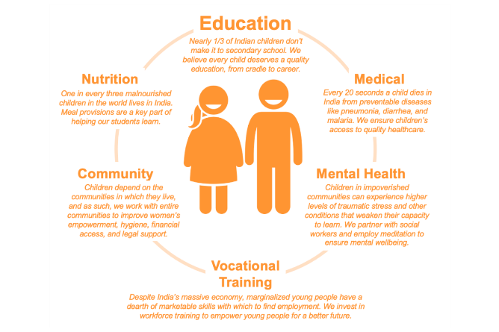
Guided by the model of CHILDREN’S HOPE INDIA, Prayas follows the approach from ‘Cradle to Career’, holistically addressing the needs that prevent children from accessing education and achieving their dreams. For this reason, our projects do more than provide schooling; we provide counseling, nutrition, healthcare, music, dance, and more. And we work with children from infancy through to young adulthood.

It aimed to provide educational support to the children, from the marginalized community of ‘Kathputli Colony’ have no access to schooling, We also strived to break the cycle of illiteracy that girls from such communities are mired in. This is done through our educators from the community coupled with trained teachers to provide meaningful and stimulating education to the children by strengthening their base followed by their admission in government school.

In 2020-21, Prayas reached out to total 435 children in the various categories, namely, Creche (2-5 years), Alternative Education (6-14 years), Remedial Education (5-15 years), Vocational Training, Computer Learning, English Speaking & Beauty Parlour including Health Services for the children and community and awareness program on children & women centric legislation.


IMPACT:


EDUCATION: 435 Children. 2345 Youth empowered



MEAL SERVED: 1,43,550. 54 Health Camps

“My whole family is thankful to Children’s Hope Prayas, which has changed our lives” - Jaswant, who participated in Children’s Hope Prayas’ educational initiatives and vocational training. Now an electrician, his two younger brothers are participating in the program and his mother takes part in the community self-help group.

GLIMPSES

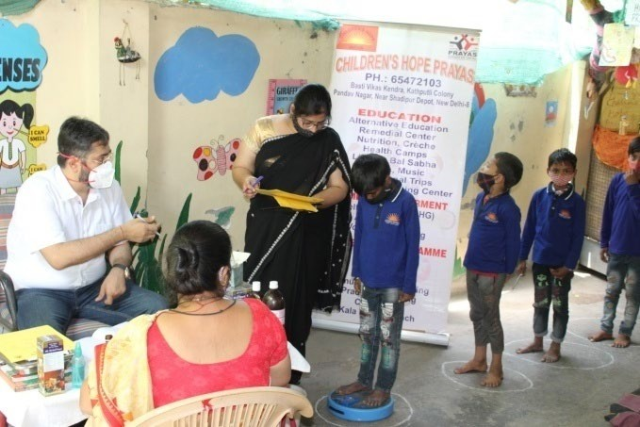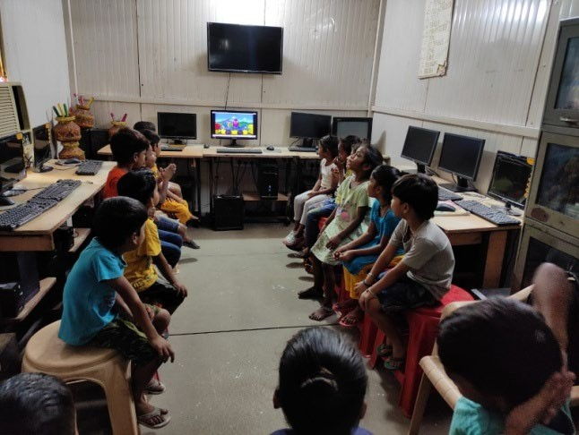

Health Examination by Dr Sumit Verma
Digital Literacy Class

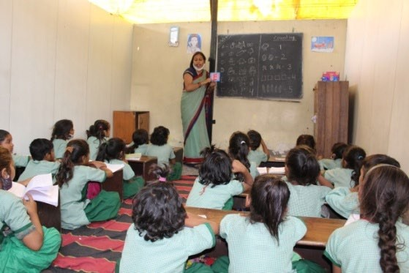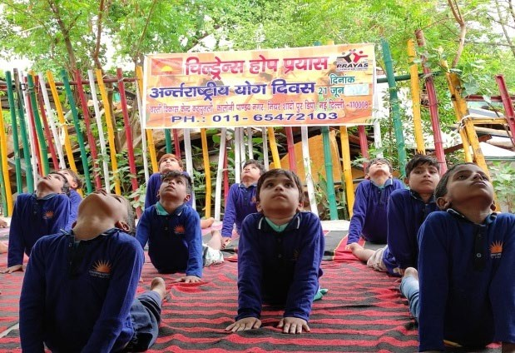
Interactive Class at Anandparvat Yoga Classes at Anandparvat
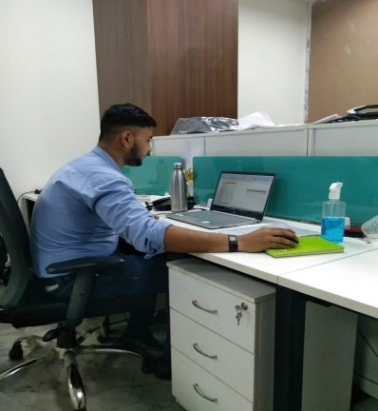
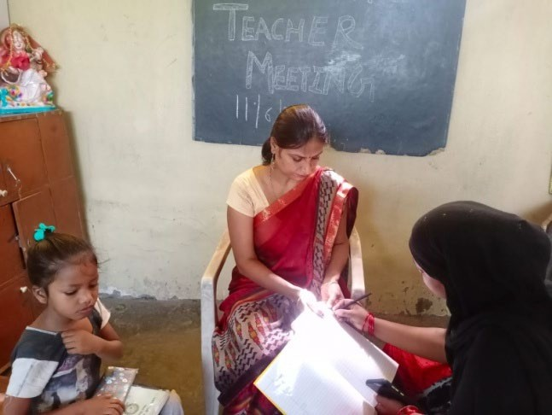 Deepak at Workplace Parent Teacher Meeting

EVERY CHILD COUnTS
STORY OF EMPOWERING LIFE
Deepak Sharma working as Purchase Executive in K.K Lighting India Private Limited at a salary of INR 2,40,000 p.a. after completion of six months Computer Course

22

NAYA PRAYAS PROJECT
Background: Naya Prayas Lalkhet Kusumpur Pahari 14 November 1993 marked the beginning of “Naya Prayas” project near Vasant Kunj township for socioeconomic upliftment of the extremely disadvantaged children, youth, and women, mostly migrants from Rajasthan, Bihar, Haryana, Uttar Pradesh, Orissa, Assam, South India, Nepal and so on for sustenance. Working as daily labourers mason, auto drivers, vegetable vendors, domestic helpers, factory workers, small time shop owners etc.
The average family income being a meagre sum ranging from Rs.2500-Rs.3000/- per month Children were working as rag pickers to support the family of eight to nine members on an average. Social evils such as drug addiction, alcoholism, prostitutions, child marriage and child labour etc were rampant. In such a challenging environment, Naya Prayas entered the lives of these people as a ray of hope. A need was felt to start with by generating awareness in the community towards the prevalent social problems, the most important being child labour followed by motivating the community and specific target group to improve their present attitudes and environment coupled with networking with local Pradhans and NGO’s working in similar or allied fields to achieve the goal following a baseline survey the Naya Prayas project started initially in Lalkhet (near Vasant Kunj) on a piece of land donated by the villagers. The organization built a two-room structure and started its operations.

The first Non-Formal Education (NFE) Center was started with eighty children. The program scaled up to the next level when Shramik Vidya Peeth extended their support and two batches of 15 women were provided training on hand embroidery. Gradually, the program size was enlarged and the beneficiaries started multiplying in each year with multiple of services started such as health camps, recreation program, legal awareness and empowerment program as well with the support from British High Commission. Naya Prayas started another centre in a space provided by the Govt.of NCT of Delhi in a two-room accommodation provided by DDA Slum in Kusumpur Basti Vikas Kendra and moved to other places such as Bhanwar Singh Camp located in Vasant Kunj where it started its Non-Formal Education Centre (NFE) in March 1995.

Total number of Children: 330 at three Education Centres located at Bhati Mines, Kusumpur Pahari and Bhanwar Singh Camp led by ASI Lakhpat Singh, Delhi Police
Education Methodology:
Active story-based Learning, in which teachers use a variety of methods such as discussion, debate, story, dance, theatre and video to engage students in the learning process;
Integrated subject teaching, in which teachers coordinate their lessons across subjects so that concepts are continuous between subject classes;
The Preschool: Age group 3+ to 5+. The curriculum for this cluster has been specially developed keeping the needs of such preschoolers who are first generation learners.
OUR CORE BELIEFS

We facilitate the change process in Communities as it possesses tremendous potential to grow


We work with communities to realize our dream of sending every child to school

14,764 Children and their Families have been empowered through education

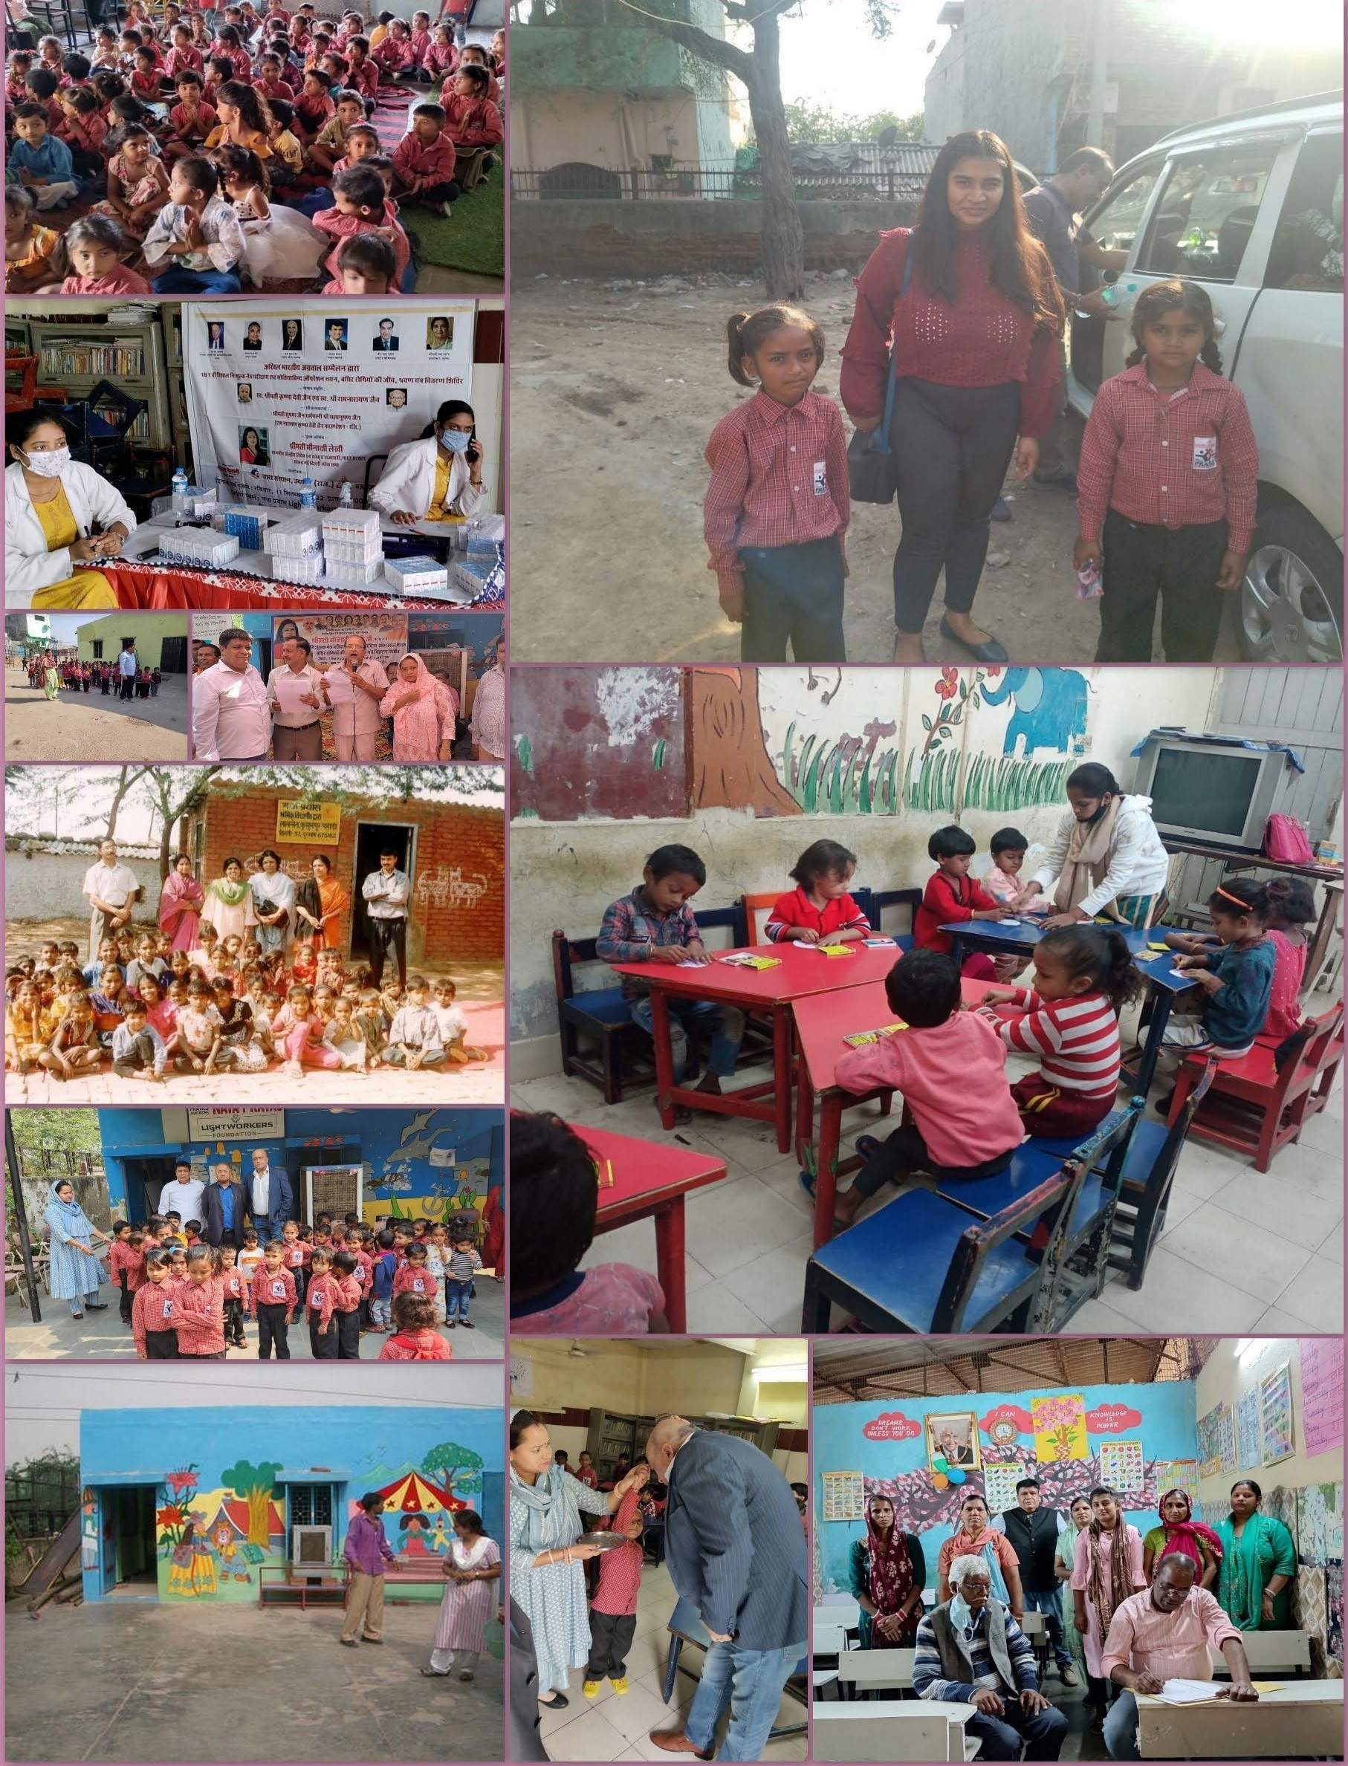


ADOPTIONSCENTRUM PROJECT

Project: Keeping Children Safe

In 2021, Prayas JAC Society strived to strengthen the child protection mechanism in the context of COVID 19 through concerted efforts in building the understanding and resilience amongst our caregivers/duty bearers/counselors/welfare officers and other support staff on risks thrown by COVID 19 and related control measures. The Project focussed on the families of the children living at the Children Home/Shelters of Prayas and also on the vulnerable & distressed families of the children restored with their families, severally, affected by the pandemic during the year.

The overall objective of Project in 2021 was to strengthened our initiative of children’s right in the society. To achieve the same, Prayas focused on accomplishment of the following outcomes:

Outcome-1: Prayas revised Child Protection and Safeguarding Policy in the context of COVID-19 is implemented in Prayas Centers

Outcome-2: Targeted Caregivers/Duty Bearers/Parents/Child Right Ambassadors are empowered to provide better support and protection to the children at risk of sexual abuse and domestic violence, considering the COVID-19 outbreak

Outcome-3: Family based care has been strengthened in order to reduce the risks of family separation and abuse within the family

Outcome-4: Children and Youth in Prayas homes and shelters have increased awareness and knowledge on SRHR and pandemic response issues
Outcome-5: Prayas as an organization has been strengthened in terms of governance, planning, legal compliance and fiscal responsibility.

In 2021, Prayas conducted 65 training session with the caregivers/duty bearers/welfare officer/counsellor/house-keeping staff/driver/volunteer/Child Right Ambassador and also with the parents of the children being placed at the Prayas Children Home for Girls and Prayas Children Home for Boys in the past six months. To ensure protection to the children from COVID-19, Prayas emphasized more on the implementation of the Child Protection Case Management during COVID-19, as we prioritize areas that all social workers, superintendent, caregivers and counsellors by creating more awareness to ensure more relevant messages being repeated over time for prevention and detection of COVID-19 as well as mainstreaming psychosocial support to the children and their family members affected from the mild and moderate symptoms of COVID-19 followed by referring the serious cases of COVID-19 to the Government Hospitals on board of Prayas JAC Society and also ensured that the children placed at the Children Home and Shelters of Prayas may not suffered due to loss of livelihoods of their family members or loss of family member due to COVID-19 by providing the psychosocial support.

Prayas also sought support from the Child Welfare Committee Members in strengthening the understanding of Case Management System amongst our caregivers and duty bearers in the context of the vulnerable children placed at the Children Home/Shelters of Prayas on the direction of the Child Welfare Committee.

All the 65 trainings/orientation and sensitization program conducted round the year based on the approved activities by the resource persons carrying decades of experience in the field of child protection either as a Child Protection Officer, Legal Officer or by a Welfare Officer.

Training Details;

Expected Outcome | Theme | Numbers
Outcome-1: Revised Child | Training on Child Protection and Safeguarding | 8
Protection and Safeguarding | Policy
Policy
 | Orientation-cum-Training Program on four | 8
 | components of Case Management to ensure
 | children protection.
 | Orientation Program on psycho-social support | 6
 | to children affected by COVID-19. Manual of
 | UNICEF was used for the same
 | Capacity Building of the Caregivers/Duty
 | Bearers on seven processes for planning an | 6
 | undertaking a Monitoring & Evaluation Plan in
 | context of the children placed at the Children
 | Home/Shelters
Outcome-2: Targeted Caregivers/Duty Bearers/Parents/Child Right Ambassadors have been empowered to provide care and protection to children at risk and violence due to COVID-19 situation | Training Program aimed to enhance awareness and to bring attitudinal shift while responding to COVID-19 Challenges  Capacity Building Program for the caregivers/duty bearers and with the parents of the children and child right ambassadors on various issues related to Children and COVID-  19 by following the guidelines of WHO and UNICEF | 8  8
 | Training-cum-Sensitization Program on response mechanism as defined under the POCSO Act 2012 and POCSO Rules 2012 and POCSO (Amendment) Rules 2020. | 4
Outcome-3: Strengthening of Family Based Care | Sensitization Program with the Caregivers/Duty Bearers/Child Right Ambassadors/Parents of the children on risk factors responsible for enhancing the vulnerability factor including the  risk of separation of the child from the family | 6
Outcome-4: Awareness amongst Children and Youth on SRHR | Training Program on legal nuances on Child Protection including Child Sexual Abuse, Health and psychological issues related to  Child Sexual Abuse | 6

 | Training on Control Mechanism in response against child sexual abuse | 4
Outcome-5: Strengthened | Capacity Building Program on governance and | 2
organizational governance, | regulatory compliances including policies
compliance and legal issues | framed and implemented in Prayas, namely,
including financial | POSH Policy, Anticorruption and Bribery Policy,
compliances and monitoring | Whistle Blower Policy, Human Resource Policy,
reports | Data Protection Policy and Ethical Standards
 | (Transparency and Fairness, Gifts and
 | Entertainment, Conflict of Interest, Fraud
 | Awareness and Segregation of Duties)

Number of People Reached

Target Group | Girls | Women | Boys | Men | Total
Direct | 165 | 214 | 275 | 436 | 1090
Indirect | 97 | 113 | 130 | 273 | 613

Lessons Learned

The lesson learned are as follows

Child Right Ambassadors played very substantial role in creating sensitivity in communities against the child sexual abuse which ultimately resulted more informed knowledge on various laws, rules and regulation covering various aspects of children related legislation.

The major responsibilities executed by the Child Right Ambassadors in their respective areas
Raised awareness about child protection issues, particularly trafficking, abuse of children at work places, violence against children, corporal punishment.

Child Right Ambassadors also acted as ‘Friend’ of Police for robust surveillance in their respective areas seeking their overall support in cases related to sexual abuse and physical abuse of children

Child Right Ambassadors ensured robust monitoring of their respective areas aimed to reduce the instances of child sexual abuse and violence


PROJECT YUVA SAMBANDH (YUVA_CONNECT)-
Deprivation to Empowerment of Children in Need of Care and Protection, (CNCP) & Youth

Prayas JAC Society supported by Jindal Steel & Power, set up ‘Centre of Excellence’ at Prayas Children Home for Girls, Tughlaqabad and Prayas Children Home for Boys, Jahangirpuri and Satellite Centres in Danapur (Bihar), Ramgarh (Jharkhand), Angul (Odisha) and Tamnar (Chattisgarh), aimed to provide holistic services to 100 children (75 Boys and 25 Girls) at CoE and 25 children each at the Satellite Centres in a residential set- up with provision of nutrition, education, life skill, sports, co-curricular activities, vocational training and career progression.

Goal

‘Marginalized & Vulnerable Children/Youth have improved access to the quality Life Skills, Education & Skill development, sports, music and co-curricular activities’

Key Objectives

- Basic requirements, such as, food, shelter, clothing, legal services, counselling, psycho- social, and medical attention as per the prescribed standards
- Appropriate education through regular schooling including supplementary education and special education for children with special needs (Provided that for the children between the age of six to fourteen years, the provisions of the Right of Children to Free and Compulsory Education under (RTE) Act, 2009 remains applicable).
- Skill development coupled with Occupational therapy and life skill education
- Mental Health interventions, including counselling specific to the needs of the child
- Recreational Activities including sports and cultural activities
- Referral Services for education, vocational training, de-addiction, treatment of diseases, wherever required.
- Case Management including preparation and follow-up of Individual Care Plan

Target Beneficiaries; Out-of-School and marginalized Children & Youth including Street, Trafficked, Missing and Run-Away, Orphaned, Abandoned, Abused and Destitute Children; Children/Youth in Conflict with Law (CCL) under After Care program, Working Children & Adolescents- those involved in Substance Abuse, affected by Conflicts and Disasters, in the families at Risk, specially-abled. Children from Impoverished families attending Day Care Education Centres of Prayas, Children presently living in our Child Care Institutions, Children of Sex Workers, Children rescued (from begging, red light areas, drug abuse etc. and similar types.

IMPACT: 06 GIRLS SCORED ABOVE 80% IN CLASS X

GLIMPSES (Education is the prime mover of the change making mission of JSP Foundation)
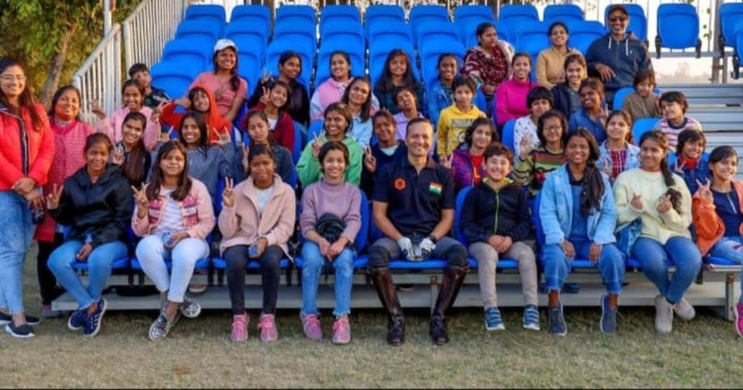
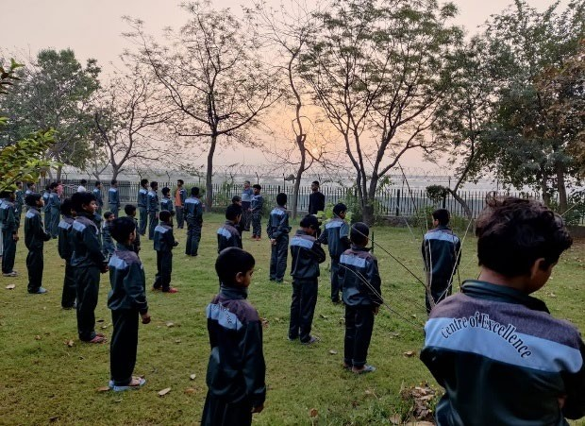
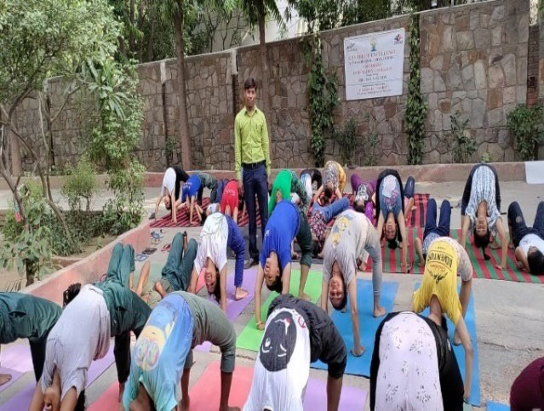
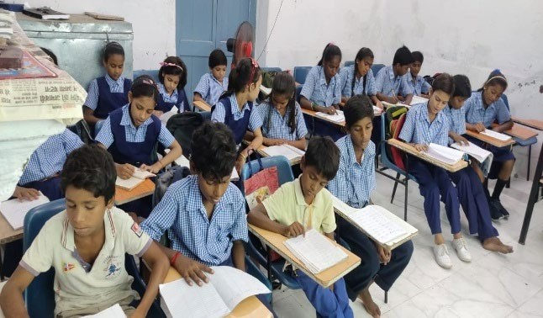

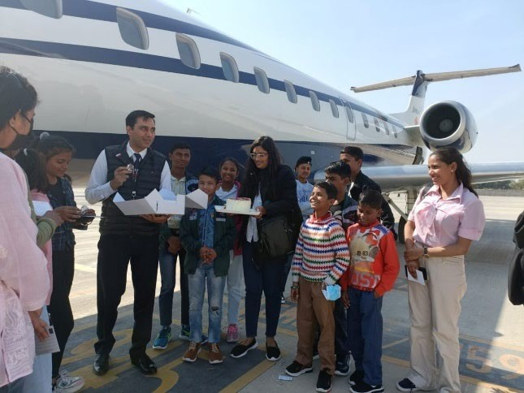
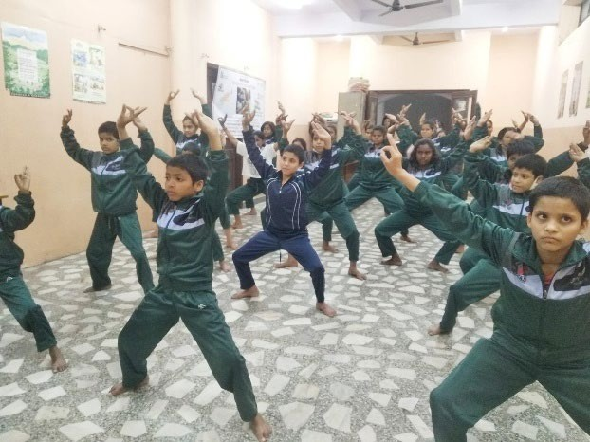

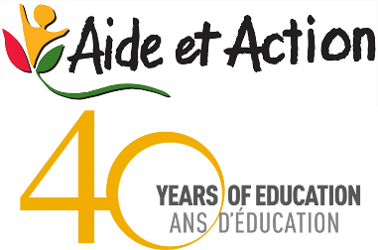
PAHAL PROJECT: PREVENTING INTERGENERATION FROM SEX WORK

“ANANYA”-PAHAL -An effort towards educating girls in difficult circumstances’

Supported by Aide-et- Action, Prayas JAC Society since 2015 working with the children of sex workers living at the Garstin Bastion Road
(officially changed to Swami Shradhanand Marg in 1966) is a road running from Ajmeri Gate to Lahori Gate, a famous red-light area. The project aimed to empower second generation girl child and their mothers from inter-generational sex work by focusing on three P’s, namely, Protection, Prevention and Prosecution to exercise their rights to safe spaces, legal protection, education, and livelihood.

The PAHAL project facilitates healthy, ready to learn children who will be provided supportive learning environments in our center with relevant curriculum content, child-centered teaching and learning resulting in successful learning outcomes for children.

The project aimed to mainstream every child to school followed by the implementation of ‘play therapy’ to make children learn how to recover from trauma and to build resilience to say ‘NO’ against violence. The project aimed to achieve the following objectives, namely,

- Enhanced identity and dignity of children and female sex workers. Change in mindset with Mothers (Female Sex Workers) and proactive actions by them for better future of their children

- Influencing the learning spaces of children to bring fundamental change in their lives and mental makeup, fully realizing that educational centers are just part of the larger learning curves of children, the following learning spaces would be targeted and influenced such as crèche, NFE, peer group of children and their homes with single mother.

- Enhanced health and access to proper nutrition by children of the commercial female sex workers

- Better visibility of the issue and gain for the partner community (Female Sex Workers and their children) from Multi Stake holders

Key Results
Sixty Children from Brothel Community are undergoing the process of CHANGE

TWO Girl child have been transitioned from ‘PROJECT PAHAL CENTRE” to CENTRE OF EXCELLENCE’ for their future development

THIRTY-FIVE CHILDREN acquainted with ‘Digital Literacy’

GLIMPSES
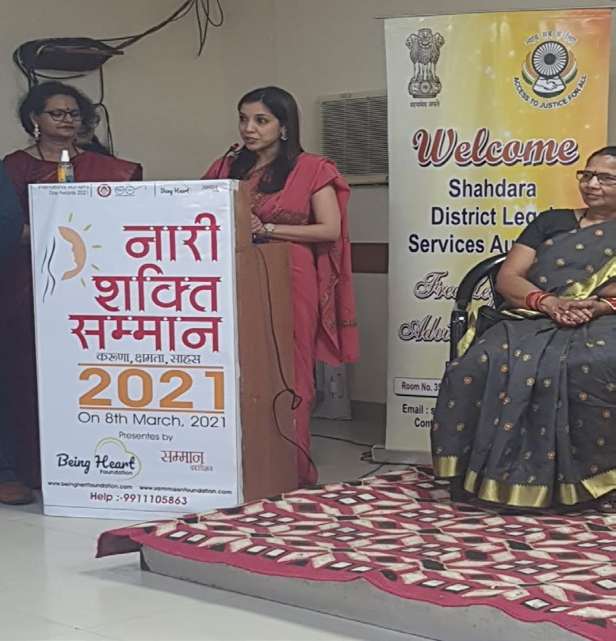
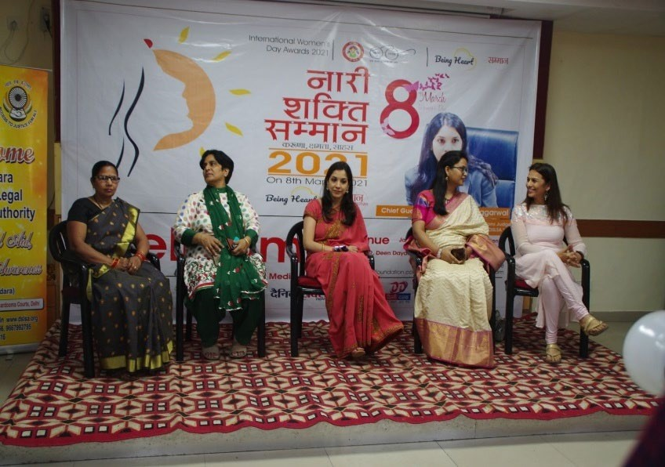
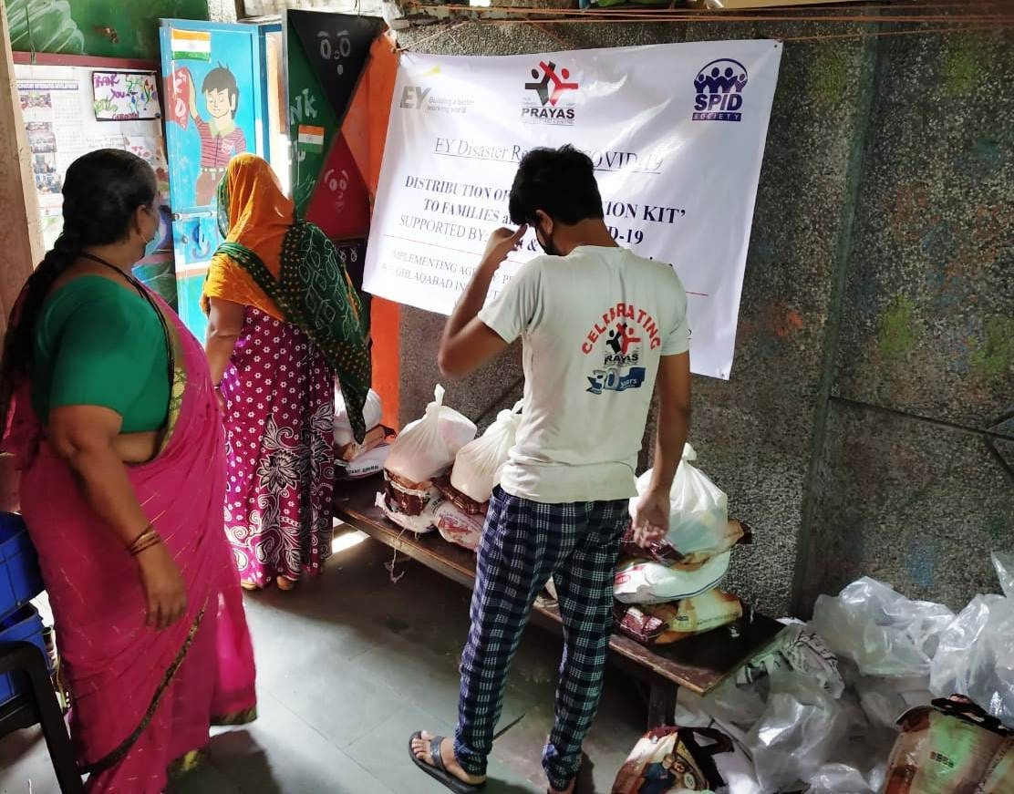
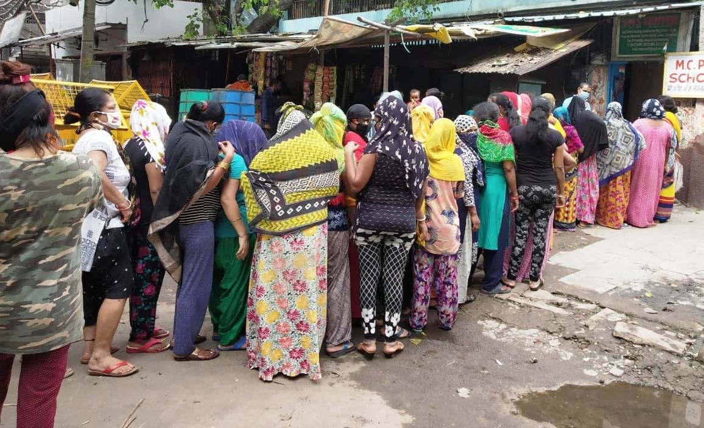
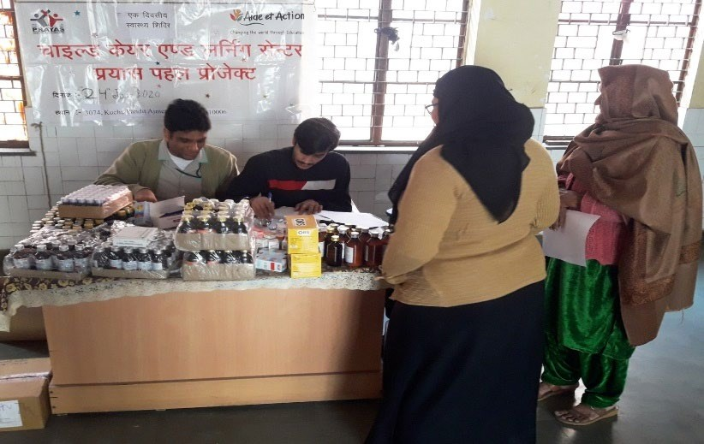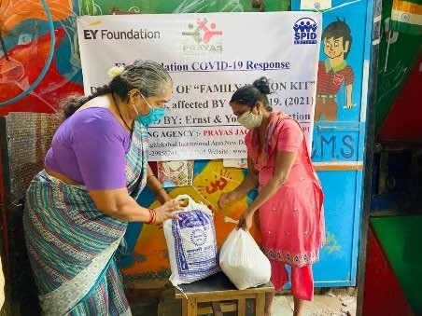

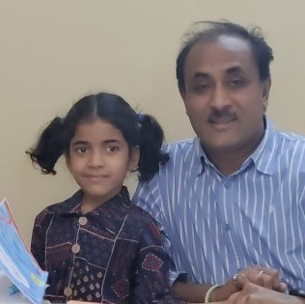
Pooja Chandra (name changed) aged 5 years started coming to Pahal Centre at the age of 4 years only along with her mother. Today, she is studying at Centre of Excellence for her better future


MAKING TOMMORROW BETTER

“Education is the most powerful weapon you can use to change the world.”-Nelson Mandela

Supported by Tenneco, Prayas further strengthened its remedial and bridge education center running from the premises of Prayas Children Home for Girls, Tughlaqabad. The Center in 2021- 22 reached out to 100 children living at the various slum communities namely Sangam Vihar, Madangir, Dakshinpuri, Tigri, Ambedkar Nagar and Devli. The majority of the population is educationally backward and challenged, due to which there is a high prevalence of orthodoxy, gender bias, alcoholism, domestic violence and lack of sensitivity and awareness about the importance of education. Hence, there is a need to work with them and introduce a new thought process and bring a positive shift in their mindset and develop a healthy and conducive environment for the learning and growth of both boys and girls.

It aimed through bridge education to provide the child the foundation for better understanding of School Curriculum and also to provide information and knowledge that is relevant to the children’s social situation. The ultimate objective will be to prepare the children to enter and complete the mainstream education as well as to prevent the child from exploitation and child labor and wandering around the streets aimlessly. A proper step will be followed for making and collection of documents required for the enrollment in schools. Admissions will be done in the school and the concept of ‘joyful learning’ and ‘play-way method of learning’ is promoted and implemented by Prayas which goes a long way in attracting the children to do the schooling.

Facts

Total Number of Children: 100
Total Number of Girls under Juvenile Justice (Care & Protection of Children) Act 2015: 40 Community Children: 60
Number of Children mainstreamed with school; 27 Number of Children scored above 80 %; 7

Components
Nutrition, Yoga, Health Services, Dance, Story Telling Session by Katha

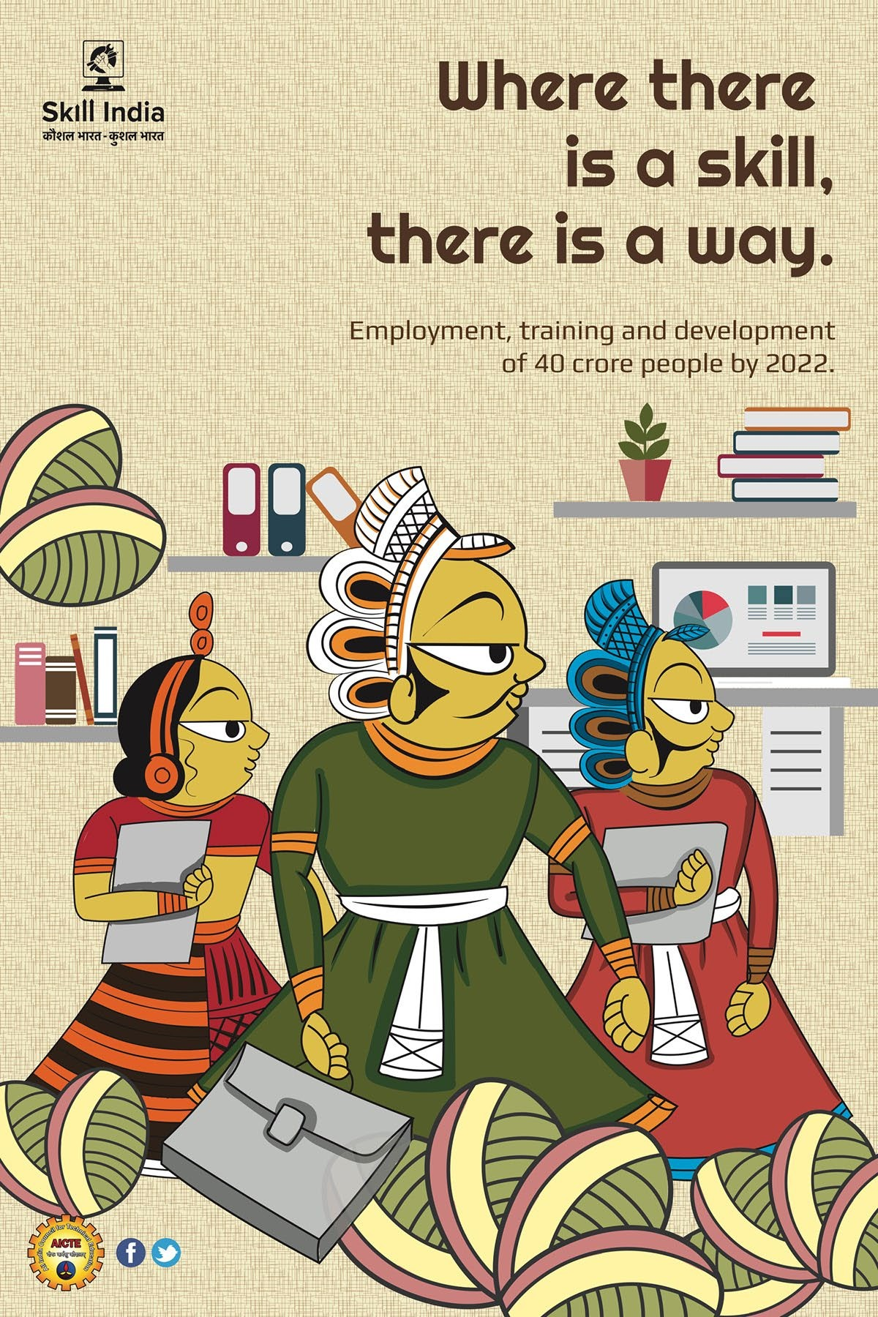

PC: SKILL INDIA, MSDE
P


कौशल fवकास और उद्यमशीलता मंत्रालय Ministry of Skill Development And Entrepreneurship
Jan Shikshan Sansthan (JSS)

Background: The Scheme of Jan Shikshan Sansthan (JSS), formerly known as Shramik Vidyapeeth is implemented through a network of NGOs in the country since March 1967. The first Shramik Vidyapeeth was established in Mumbai [Worli] and was commissioned by Bombay City Social Council Education Committee, a voluntary organisation engaged in the field of Adult Education. After the success of the project, the Govt. of India developed a scheme for setting up a network of such institutions in the country in a phased manner.

With the transformation in the economic and social setup over the years, the role and scope of these polyvalent educational institutions have widened manifold. In the changed scenario, the focus of Shramik Vidyapeeth (SVP) was shifted from industrial workers in urban areas to the non-literates, neo-literates, unskilled and unemployed youth particularly from SC/ST/OBC/Minority/Divyang/Women throughout the country especially to underprivileged people in the rural areas. The SVPs were accordingly renamed as Jan Shikshan Sansthan (JSS)
w.e.f. year 2000.

The scheme of Jan Shikshan Sansthan was consequently transferred from Ministry of Education (erstwhile MHRD) to Ministry of Skill Development and Entrepreneurship (MSDE) in July 2018.

Objective:
    - To improve the occupational skills and technical knowledge of the non/neo literates and persons having rudimentary level of education upto 8th standard and other school dropouts beyond 8th standard i.e, up to class 12th to raise their efficiency, increase productive ability and enhance their livelihood opportunities
    - To identify and promote traditional skills in the districts through skilling/upskilling
    - To create a pool of master trainers working across the department/agencies of skill development through training/orientation program
    - To collaborate and coordinate with other departments/agencies working in the field of skill development
    - To widen the range of knowledge and understanding of social, economic, and political systems and create awareness about the environment
    - To Promote national values and to align with national program
    - To promote self-employment and facilitate to get financial support including loans/ for the target groups through linkage with credit and consortium membership

PRAYAS JAC Society is running five Jan Shikshan Sansthan at the following places, namely Delhi (Jahangirpuri), Samastipur (Bihar), Jamui (Bihar), Ramgarh (Jharkhand) and South Andaman in Andaman & Nicobar Islands. The JSS at Jamui, Ramgadh and South Andaman started in October 2021 under the respective leadership of Chairman Mr. Amod Kanth (JSS

Jahangirpuri) and Director Ms. Sadhana Srivastav, Chairman Dr Supriyo Mukherjee (JSS Samastipur) and Director Mr. Amardeep Sinha, Chairman Mr. Harish Nandan Sahay (JSS Jamui) and Director Mr. Manoj Kumar Sinha, Chairman Mr. Amod Kanth (JSS Ramgadh) and Director Mr. Anubhav Ankit and Chairman Mr. Jasvir Malik (JSS Andaman) and Director Ms. Maria Sheila as Director.

The details of vocational courses conducted in 2020-21, by all the three JSS are as follows started in October 2021.

S. No | Trade | Andaman |  | Jamui |  | Ramgarh
S. No | Trade | Batches Conducted | Beneficiaries Trained | Batches Conducted | Beneficiaries Trained | Batches Conducted | Beneficiaries Trained
1 | Self Employed Tailor | 20 | 400 | 11 | 220 | 11 | 220
2 | Traditional  Hand Embroidery | 8 | 160 | 5 | 100 | 5 | 100
3 | Assistant Beauty Therapist | 20 | 400 | 9 | 180 | 9 | 180
4 | Bamboo Basket Maker | 8 | 160 | 2 | 40 | 2 | 40
5 | Applique Artisan | - | - | 2 | 40 | 2 | 40
6 | Frontline Health Workers |  |  | 2 | 40 | 2 | 40
7 | Domestic Data Entry Operator | 8 | 160 | 2 | 40 | 2 | 40
8 | Painting Helper | - | - | 2 | 40 | 2 | 40
9 | Jam, Jelly and Ketchup Processing  Technique | - | - | 2 | 40 | 2 | 40
10 | Pickle Making Technique | - | - | 2 | 40 | 2 | 40
11 | Assistant Carpenter- Wooden  Furniture | - | - | 2 | 40 | 2 | 40
12 | Stringing/Beadi ng Artisan | - | - | 2 | 40 | 2 | 40
13 | Mushroom Grower | - | - | 2 | 40 | 2 | 40

33

14 | Assistant Welder &  Fabricator | 04 | 80 | - | - | - | -
15 | Assistant Fruit &  Vegetable Processing | 10 | 200 | - | - | - | -
16 | Assistant Plumbing &  Sanitary Work | 2 | 40 | - | - | - | -
17 | Domestic/Helpe r | 2 | 40 | - | - | - | -
18 | Helper Electrical Technician | 4 | 80 | - | - | - | -
19 | Artisan Bamboo | 8 | 160 | - | - | - | -

B. Status of Vocational Courses initiated by JSS Jahangirpuri (New Delhi) and JSS Samastipur (Bihar)

S.No | Trades | JSS Jahangirpuri |  | JSS Samastipur
S.No | Trades | Batches  Conducted | No of  Beneficiaries | Batches  Conducted | No of  Beneficiaries
1 | Nursery Worker |  |  | 2 | 40
2 | Mushroom Grower (Small  Entrepreneur) |  |  | 3 | 60
3 | Hand Embroiderer  (Addawala) | 4 | 80 | 5 | 100
4 | Self Employed Tailor | 14 | 280 | 5 | 100
5 | Sewing Machine Operator-  Knits |  |  | 25 | 500
6 | Welding Assistant |  |  | 1 | 20
7 | Assistant Hair Stylist | 4 | 80 | 10 | 200
8 | Assistant Beauty Therapist | 22 | 240 | 7 | 140
9 | Home Cook |  |  | 4 | 80
10 | Electrical Technician | 4 | 80 | 3 | 60
11 | Pickle Making Technician |  |  | 4 | 80
12 | Assistant Carpenter-Wooden Furniture |  |  | 2 | 40
13 | Domestic Data entry Operator |  |  | 10 | 200
14 | Unarmed Security Guard |  |  | 1 | 20
15 | Plumber (General) Assistant | 4 | 80 | 2 | 40
16 | Retail Store Ops Assistant | 2 | 40 | 1 | 20
17 | Room Attendant |  |  | 4 | 80
18 | Field Technician - Other Home  Appliances | 6 | 120 | 1 | 20
19 | Domestic Worker (Child Care  Taker) | 2 | 40 | - | -
20 | Domestic Worker (Elderly Care  Taker) | 2 | 40 | - | -
21 | Domestic Worker (Non-Clinical) | 2 | 40 | - | -

22 | Stringing/Beading Artisan | 4 | 80 | - | -
23 | Lacquerer (Paper Mache) | 5 | 100 | - | -
24 | Traditional Hands Embroiderer | 2 | 40 | - | -
25 | General Duty Assistant | 4 | 80 | - | -
26 | Decorative Painter Glassware | 2 | 40 | - | -
27 | Agriculture-Nursery Worker | 2 | 40 | - | -
28 | Jute Product Stitching Operator | 3 | 60 | - | -
29 | Jute Product Maker | 2 | 40 | - | -

GLIMPSES

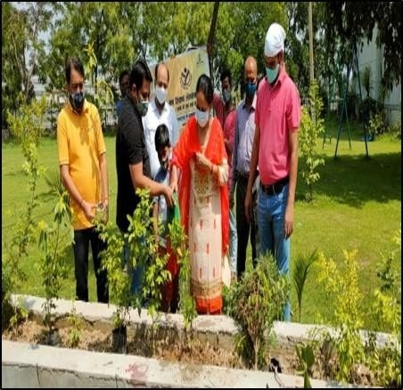
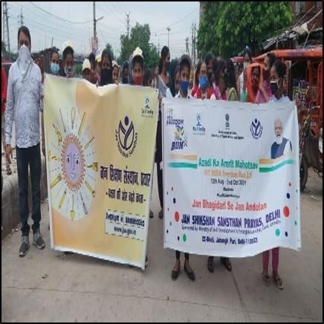

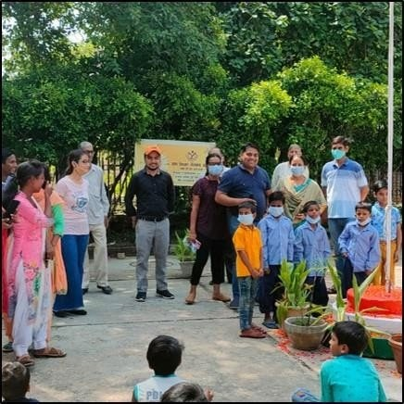
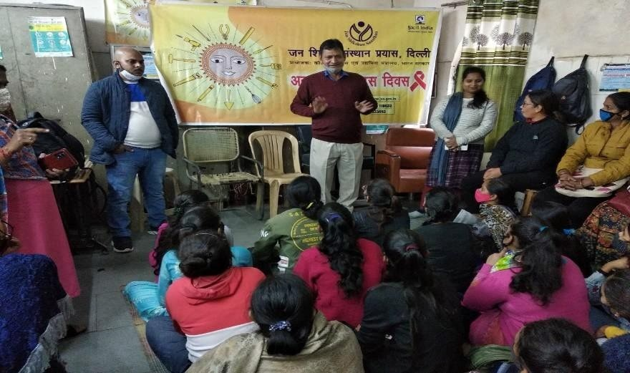


PRAYAS INSTITUTE OF ECONOMIC EMPOWERMENT

Prayas JAC Society partnered with National Skill Development
Corporation (NSDC) in 2015. We are authorized NSDC Partner and offers market-led fee- based courses which are standardized NSQF aligned (National Skills Qualification Framework) programs. NSDC / SSCs certificates are nationally recognized given its standardization in content and assessments

Our programs as Pradhan Mantri Kaushal Vikas Yojana and also as partner of ‘Fees Based Model’, range across various levels of the National Skills Qualifications Framework (NSQF) and cater to a wide range of learner segments ranging from school dropouts and diploma holders to undergraduates and graduates as well as working professionals. Additionally, training in functional English, digital literacy and life skills marks our commitment to helping students become completely job-ready.

The details of our Training Program under various trades are given below

Centers | Job Role | Enrolled | Complete | Dropout | Ongoing | Total | Placement Status
 |  |  |  |  |  |  | Salaried/Sel f Employed
Jahangirpuri | IT | 58 | 58 | 0 | 0 | 58 | 13
Jahangirpuri | Apparel | 0 | 0 | 0 | 0 | 0 | 0
Jahangirpuri | B & W | 15 | 15 | 0 | 0 | 15 | 6
Jahangirpuri | Assistant Electrician | 73 | 73 | 0 | 0 | 73 | 28
Jahangirpuri | Retail | 25 | 25 |  | 0 | 25
Jahangirpuri | Total | 171 | 171 | 0 | 0 | 171 | 47
T.Bad | IT | 83 | 77 | 6 | 0 | 83 | 18
T.Bad | Apparel | 10 | 10 | 0 | 0 | 10 | 5
T.Bad | B & W | 34 | 30 | 4 | 0 | 34 | 13
T.Bad | Total | 127 | 117 | 10 | 0 | 127 | 36
Samastipur | IT | 15 | 15 | 0 | 0 | 15 | 0
Samastipur | Apparel | 0 | 0 | 0 | 0 | 0 | 0
Samastipur | B & W | 15 | 15 | 0 | 0 | 15 | 0
Samastipur | Total | 30 | 30 | 0 | 0 | 30 | 0
PoothKhurd | IT | 29 | 25 | 4 | 0 | 29 | 12
PoothKhurd | Apparel | 0 | 0 | 0 | 0 | 0 | 0
PoothKhurd | B & W | 15 | 15 | 0 | 0 | 15 | 6
PoothKhurd | Electrical | 25 | 20 | 5 | 0 | 25 | 9
PoothKhurd | Total | 69 | 60 | 9 | 0 | 69 | 27
Astha Prayas | IT | 32 | 32 | 0 | 0 | 32 | 0

 | Apparel | 0 | 0 | 0 | 0 | 0 | 0
 | B & W | 0 | 0 | 0 | 0 | 0 | 0
 | Total | 32 | 32 | 0 | 0 | 32 | 0
Bawana | IT | 0 | 0 | 0 | 0 | 0 | 0
Bawana | Apparel | 0 | 0 | 0 | 0 | 0 | 0
Bawana | B & W | 20 | 20 | 0 | 0 | 20 | 0
Bawana | Total | 20 | 20 | 0 | 0 | 20 | 0
Jhandewalan | IT | 15 | 15 | 0 | 0 | 15 | 7
Jhandewalan | Apparel | 0 | 0 | 0 | 0 | 0 | 0
Jhandewalan | B & W | 15 | 15 | 0 | 0 | 15 | 8
Jhandewalan | Total | 30 | 30 | 0 | 0 | 30 | 15
Mangolpuri | IT | 103 | 103 | 0 | 0 | 103 | 22
Mangolpuri | Apparel | 111 | 111 | 0 | 0 | 111 | 35
Mangolpuri | B & W | 114 | 114 | 0 | 0 | 114 | 37
Mangolpuri | GDA | 53 | 53 | 0 | 0 | 53 | 44
Mangolpuri | Total | 381 | 381 | 0 | 0 | 381 | 138
Narela | IT | 133 | 133 | 0 | 0 | 133
Narela | Apparel | 104 | 104 | 0 | 0 | 104 | 41
Narela | B & W | 109 | 109 | 0 | 0 | 109 | 41
Narela | GDA | 55 | 55 | 0 | 0 | 55
Narela | Total | 401 | 401 | 0 | 0 | 401 | 82
Wazirpur | IT | 120 | 120 | 0 | 0 | 120 | 35
Wazirpur | Apparel | 112 | 112 | 0 | 0 | 112 | 28
Wazirpur | B & W | 120 | 120 | 0 | 0 | 120 | 37
Wazirpur | Total | 352 | 352 | 0 | 0 | 352 | 100
Ramgarh | Retail | 25 | 25 | 0 | 0 | 25 | 12
Ramgarh | Apparel | 0 | 0 | 0 | 0 | 0 | 0
Ramgarh | B & W | 0 | 0 | 0 | 0 | 0 | 0
Ramgarh | Total | 25 | 25 | 0 | 0 | 25 | 12
 | Total | 1638 | 1619 | 19 | 0 | 1638 | 457

PRAYAS HOMELESS PROJECT
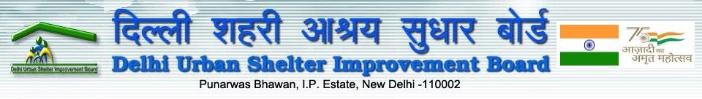
The National Urban Housing & Habitat Policy (NUHHP), 2007 aims at promoting sustainable development of habitat in the country with a view to ensuring equitable supply of land, shelter, and services at affordable prices to all sections of the society. However, the most vulnerable of these are the urban homeless.

The Urban homeless persons contribute to the economy of the cities and thus the nation
as cheap labour in the informal sector; yet they live with no shelter or social security protection. The urban homeless survive with many challenges like no access to elementary public services such as health, education, food, water and sanitation. National Urban Livelihoods Mission (NULM) aims at providing permanent shelter equipped with essential services to the urban homeless in a phased manner under the Scheme of Shelter for Urban Homeless (SUH).

Objective
Ensure availability and access of the urban homeless population to permanent shelters including the basic infrastructure facilities like water supply, sanitation, safety, and security; Cater to the needs of especially vulnerable segments of the urban homeless like the dependent children, aged, disabled, mentally ill and recovering gravely ill, by creating special sections within homeless shelters and provisioning special service linkages for them.

Provide access to various entitlements, viz. social security pensions, PDS, ICDS, identity, financial inclusion, education, affordable housing etc. for homeless populations.

Formulate structures and framework of engagement for development, management and monitoring of shelters and ensuring basic services to homeless persons, by state and civil society organizations including homeless collectives.

Facilities at Prayas Shelters: The shelters will be permanent, running though out the year; and open round the clock, because many homeless persons find work in the nights. Following facilities/amenities may be provided at the shelters for dignified living: Well- ventilated rooms. Water arrangements (Potable drinking water and other needs) and sanitation, Adequate bathing & toilet facilities, Standard lighting for shelter, Adequate fire protection measures, as per the norms, First aid kit. Pest and vector (mosquito) control, Regular cleaning of blankets, mattresses and sheets, and maintenance of other services, Common kitchen/cooking space, necessary utensils for cooking and serving, cooking gas connections etc. Child care facilities for children by linking the shelter to the nearest Anganwadi Centers, Facilitation for convergence with other services/entitlements.

Linkages with Entitlements
Shelters will be a space for convergence and provisions of various entitlements of social security, food, education, and health care systems. All homeless persons, in shelters should be given priority under various schemes, and government programs.

Identity Proof & Postal Address, Elector’s Photo Identity Card (EPIC), etc. Old age, widows and disability pensions, BPL cards, PDS ration cards, etc. Bank or post office accounts, ICDS services, Admission to government schools, Rashtriya Swasthya Bima Yojana, Admissions to public hospitals for health care, Free Legal Aid

Prayas SHELTERS IMPACT
Shelter Code Number | Address
Code No 145 | Ganesh Nagar Near  Mother Dairy
Code No-69 | Trilokpuri BVK Block 31,  Near Gas Godown
Code No-130 | Geeta Colony Shamshan  Ghat
Code No-204 | Chand Cinema Kalyanvas
Code No-111 | Chilla Goan, Near Hotel  Hilton, Mayur Vihar
Code No-142 | Opposite Mayur Vihar Metro Station, Yamuna  Khadar
Code No-192 | 7 IFC Pocket C, Ghazipur
Code No-95 | Shakarpur (Laxmi Nagar), Near Railway Flyover,  Akshardham
Code No-131 | Akshardham Temple
Code No-118 | Nangli Khadar, Near Ram  Charitra Manas Temple, Near Mayur Vihar
Code No-150 | Nangli Chilla Khadar  Village, Near Mayur Vihar
Code No-196 | 1st & 2nd Floor, Geeta  Colony
Code No-197 | 3rd Floor, Geeta Colony.

Urban Homeless are the most vulnerable section who epitomizes explicit social exclusion. Homeless People are understood as those who do not live in ‘census house’ by the Census of India. The Homelessness debate often revolves around the lack of house. One of the major causes of the homelessness as per respondent’s view is poverty and homelessness is seen as poverty problem not as housing. Unemployment is the second big cause which pushes people into homelessness. Bhanu Pratap Singh who was living on streets of Delhi, rescued from the Prayas Homeless Team in 2015. According to him, he is from Pratapgarh and left home one day after his bitterness with his wife reach to the point of separation due to her illicit relationship with her boyfriend even after her marriage. Since then, he never returned home. Bhanu today works as a Plumber in Prayas after undergoing the training of six months.

GLIMPSES

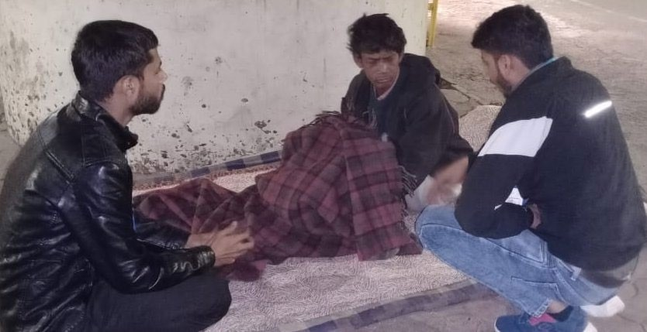
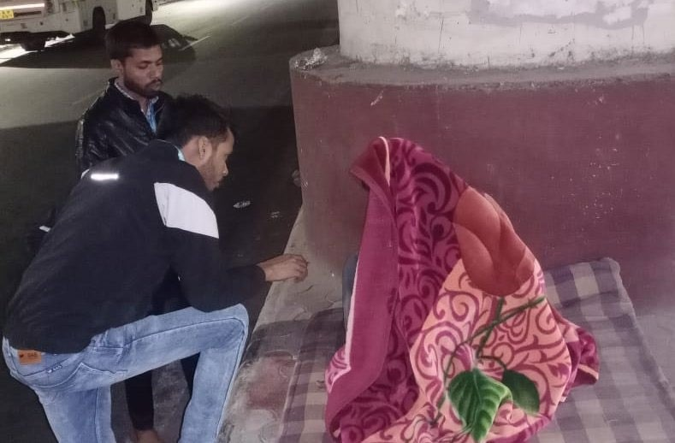
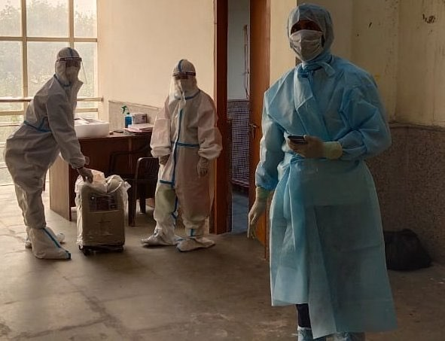
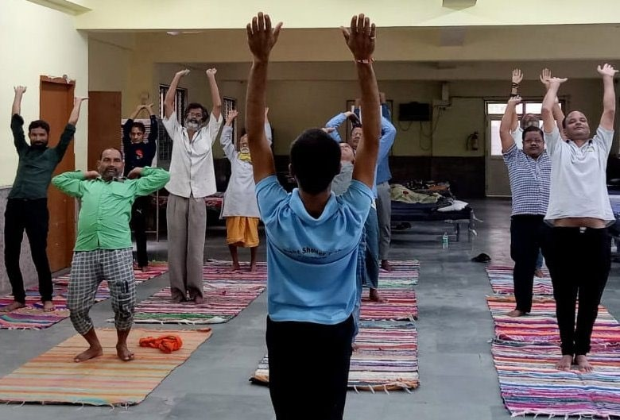
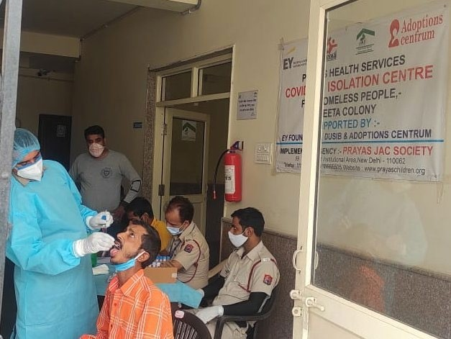
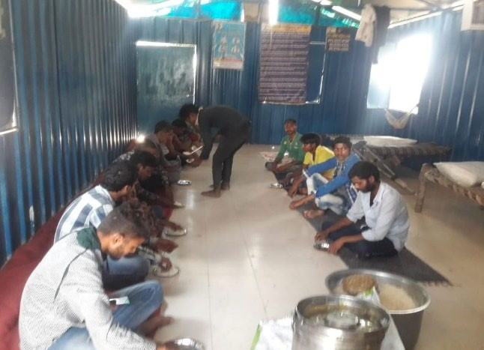
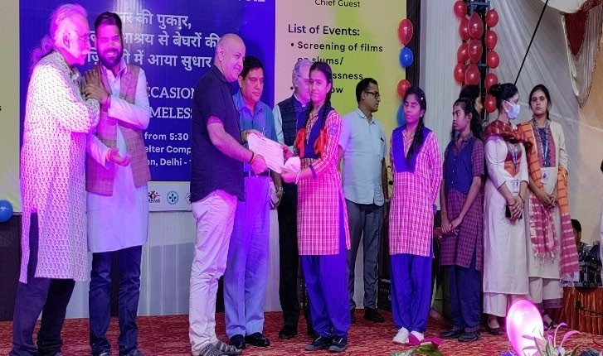
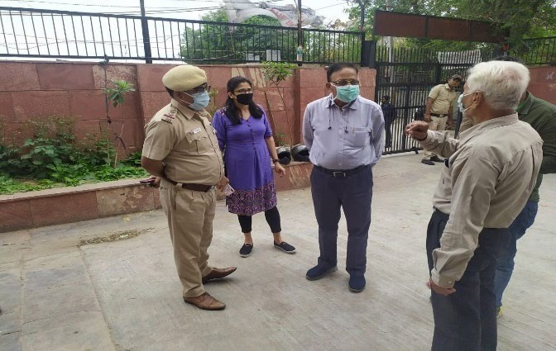

PRAYAS HEALTH PROJECT


Prayas JAC Society is continuously pursuing the vision of providing an equitable and integrated model of healthcare in Delhi and Arunachal Pradesg through education and livelihood by empowering marginalize
d people to be self-reliant. The intervention of Prayas Health Services has been consistently on Public Private Partnership
(PPP) model which was initially piloted in collaboration with the Department of Health & Family Welfare Government of Arunachal Pradesh.
Prayas Janhit Swasthya Seva Sansthan, a unit of Prayas JAC Society is running Community Health Centre, Wakro and Sub-Centres at Medho, Tillai, Karhee and Kathan. Total Population of Wakro is 5520 and Total Household is 887

SERVICES
OPD Services, Emergency Services @ 24*7 IMPACT
Total registration | 11828 | 11493 | 12636 | 13411 | 12817 | 13517 | 12370 | 12812 | 11982 | 11428 | 8211 | 8236
Early registration | 7277 | 6692 | 8736 | 9756 | 9999 | 10328 | 9756 | 10565 | 9810 | 9443 | 8777 | 7119
% of Early Registration | 62 | 58 | 69 | 73 | 78 | 80 | 81 | 83 | 84 | 82 | 86.18 | 86
TT Coverage | 10932 | 10847 | 11436 | 13039 | 12423 | 14004 | 10679 | 12090 | 11842 | 11339 | 8221 | 8356
Deliveries | 8255 | 9489 | 10063 | 11031 | 10828 | 12190 | 10683 | 11512 | 11062 | 10395 | 7193 | 7206
Institutional deliveries | 4645 | 5929 | 7813 | 10234 | 10374 | 11799 | 10402 | 11276 | 10889 | 10351 | 7177 | 7323
% of institutional deliveries | 56 | 62 | 77 | 93 | 96 | 97 | 98 | 98 | 98 | 99 | 99.78 | 99.91
Maternal deaths | 5 | 6 | 9 | 13 | 10 | 11 | 4 | 5 | 3 | 5 | 2 | 1
Live births | 8349 | 9033 | 10004 | 10899 | 10676 | 12071 | 10002 | 11410 | 10951 | 10308 | 7169 | 7319
Still births | 93 | 74 | 167 | 156 | 133 | 123 | 128 | 104 | 49 | 45 | 30 | 24
Infant deaths | 163 | 180 | 220 | 225 | 192 | 162 | 110 | 95 | 108 | 98 | 37 | 39
IMR | 20 | 20 | 22 | 21 | 18 | 13 | 11 | 8.3 | 9.8 | 8.8 | 5.1 | 5.3
MMR | 60 | 66 | 90 | 119 | 93 | 91 | 40 | 44 | 27.4 | 48.5 | 27.9 | 13.6

Early Antenatal Care (ANC) Registration: Early Ante Natal Checkup registration is defined as women who have registered in the PHC within first trimester (12 weeks) of pregnancy. Percentage of ANC registration in first trimester shows early care and level of awareness in

the community. There has been a steady improvement in the % of ANC Registration in the catchment area of PHCs managed by PRAYAS HEALTH SERVICES

Percentage of Institutional Delivery: Deliveries conducted at public or private institution/ facility are considered as Institutional Deliveries, which aim at avoiding home deliveries, resulting in reduction of maternal and infant mortalities. The health workers have a key role in educating and encouraging the community for institutional deliveries. Prayas Janhit Swasthya Seva Kendra has consistently achieved over 99% institutional deliveries for the past year in Wakro, Lohit District, Arunachal Pradesh

Maternal Mortality Rate: Maternal Mortality Rate (MMR) is the number of female deaths per 100,000 live births from any cause related to or aggravated by pregnancy or its management (excluding accidental or incidental causes). MMR includes deaths during pregnancy, childbirth, or within 42 days of termination of pregnancy, irrespective of the duration and site of the pregnancy for a specified year. Training and capacity building have motivated our health workers to bring down the MMR significantly in the population we serve.

GLIMPSES

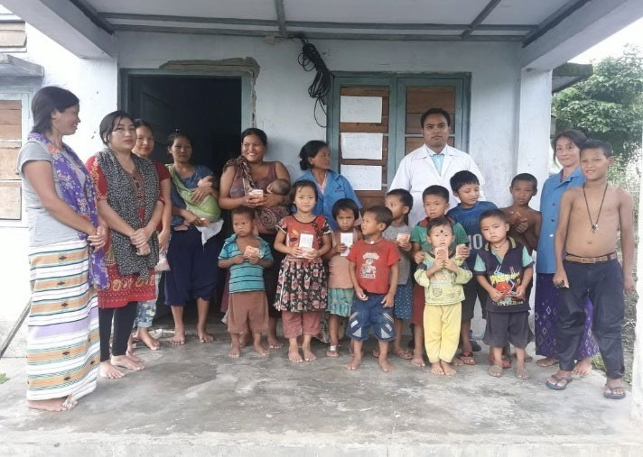
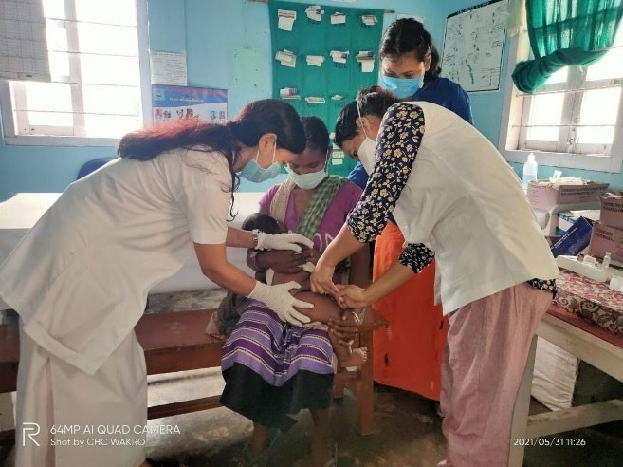
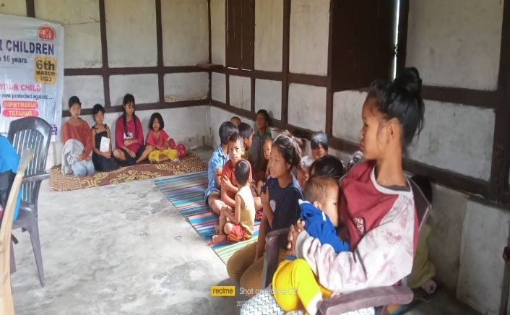

42



The primary objective of the program was the recovery and mainstreaming of the victims (children) and their families keeping in mind the impact of Covid-19 on the vulnerable.
The program through its multiple components identified key deliverables for recovery and rehabilitation. Pursuant to this, the program was able to put children on a path of effective and sustainable recovery by enrolling them on formal / non-formal education. The children were successfully associated with relevant government schemes and policies with the primary focus being on compensation to the victims of child labour and trafficking. The secondary beneficiaries were identified to be associated with government schemes and livelihood program The beneficiaries were further mainstreamed by facilitating the registration of families with government welfare schemes and through the creation of the requisite identity cards for families and children.

Component ; (Enrollment in Education- Formal/ Non-Formal), (Government Schemes/ Livelihood Program support to Families), (EBRP Support), (Compensation, Access to Schemes / Recovery Entitlements for children), (Counselling Support)
PROTECTING CHILDREN: THE STORY OF RAMU DAS
Child's name: Ramu Das [Name changed] Age: 12 years, Father: Ram Binay Das, Mother: Baby Devi, Village Post: Govindpur Khajuri, Police Station: Kalyanpur, District: Samastipur, Bihar. The father of the child, Ram Vinay Das used to work as a daily wage labourer in his area and the mother is a housewife. Ram Vinay Das has two boys and a girl. Child Ramu Das was studying in 5th class. Due to the several lockdowns in Covid-19, the father of the child was not able to get work every day, due to which his financial condition had worsened, and was also facing a lot of difficulties in fulfilling the basic needs of the family. Taking advantage of this situation and keeping the mother of the child, Baby Devi, under false impression, the trafficker through agent took the child Ramu Das to Jaipur for work in the bangle factory. After some months, the child Ramu was rescued by rescue teams in Jaipur and was repatriated back to Samastipur. We did coordination regarding complete information about this with CWC and District Child Protection Unit. When our team met the child and his family for the first-time post repatriation, at that time the child and his family were very scared & were not sharing or telling us anything. Through our continuous follow-ups, we managed to convince them that we wished best for them. Previously, all three children in the family were dropouts from school. First of all, we organized a meeting with the family and the people in the neighbourhood and many topics such as, importance of education in life and policies of the government for our development, were discussed in detail. Eventually, children were re-enrolled in school, now Ramu Das is studying in class six, elder sister in ninth & younger brother in standard fourth. Simultaneously, more children of the same community have been enrolled. Now all the children are going to school every day. Mother Baby Devi has been connected with the livelihood group along with helping her in taking a loan from the government for self-employment. Her husband Ramvinay Das is doing the work of a mason. Just a few days ago, her name has been registered with the Municipality. Some female employees have to be reinstated to give daily broom in their area, for which application of mother Baby Devi has also been submitted by us, so that the future of the child and family is good. Along with this, the family has also been linked to the scheme e-Labor card, run by the Labour Department. Child's enrollment in CLTS and opening of bank account has also been done to ensure the child’s rehabilitation through Central Sector Scheme and Chief Minister's Relief Fund. Now the child and his family are very happy.

FINANCIALS OF PRAYAS

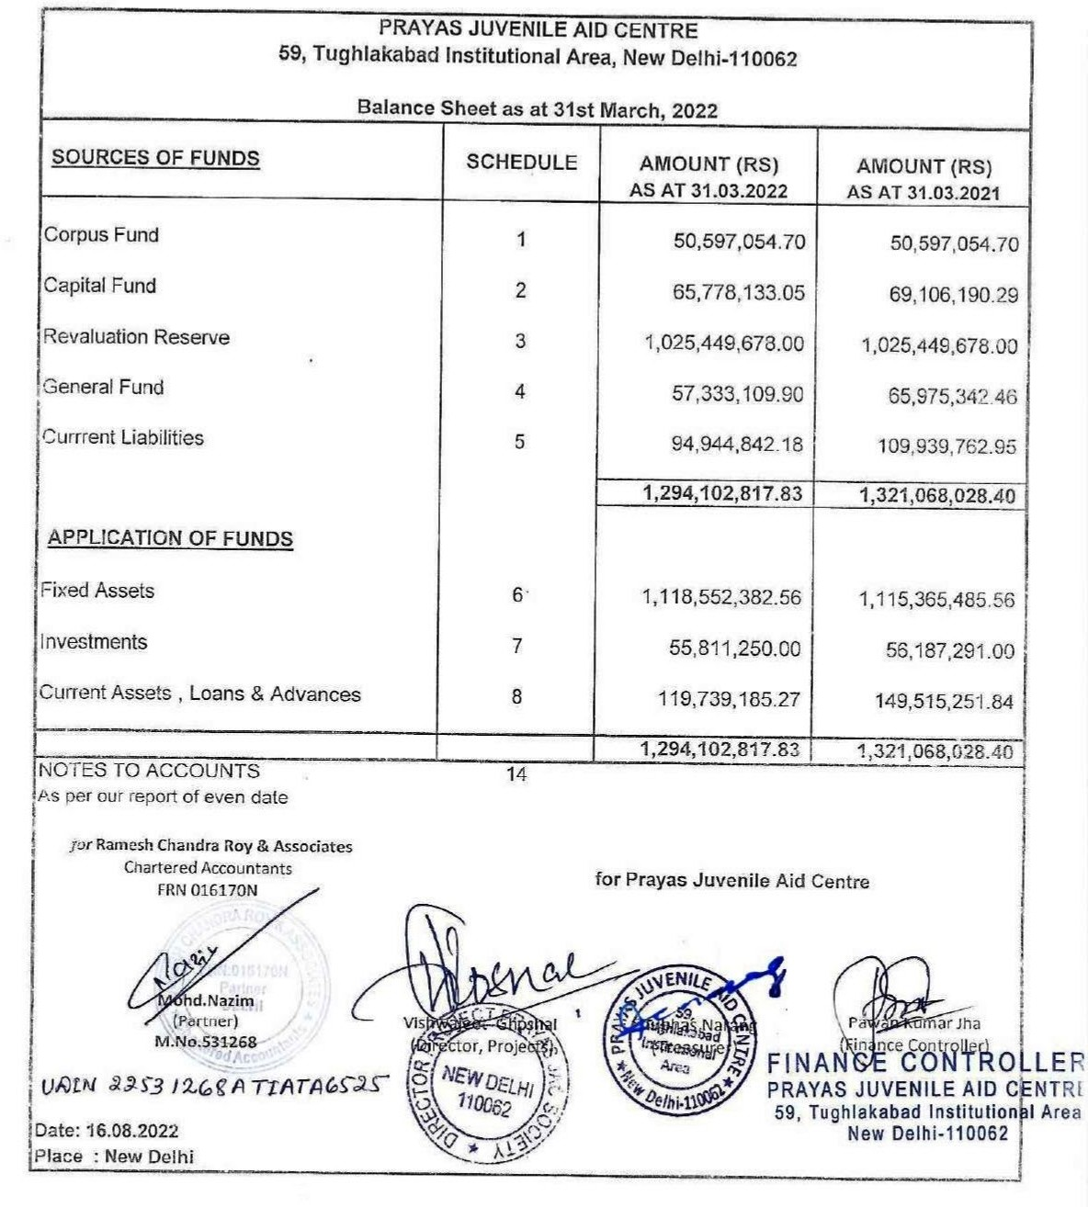

44

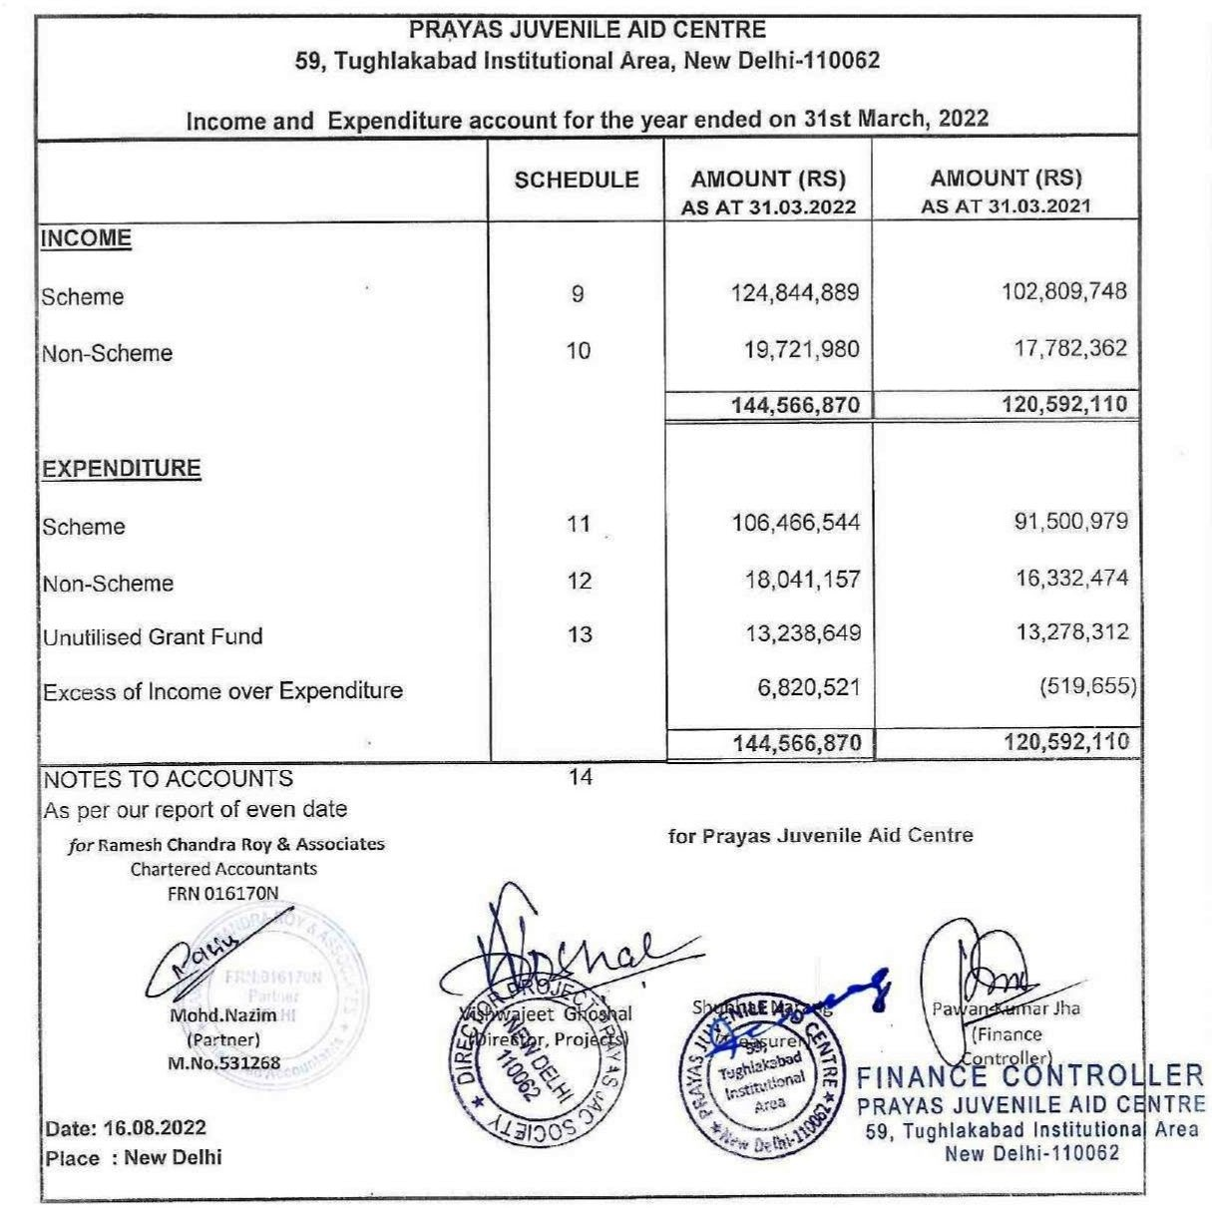

OUR SINCERE GRATITUDE


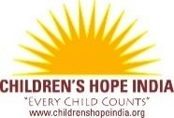
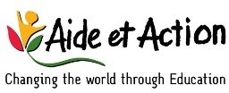








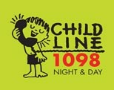
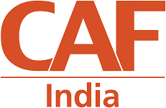

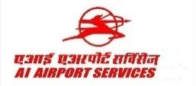

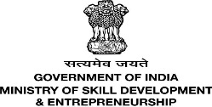


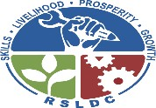

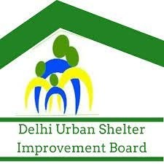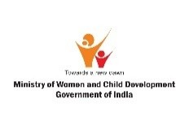


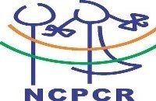
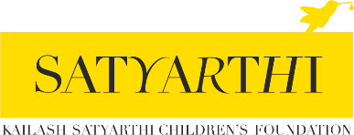

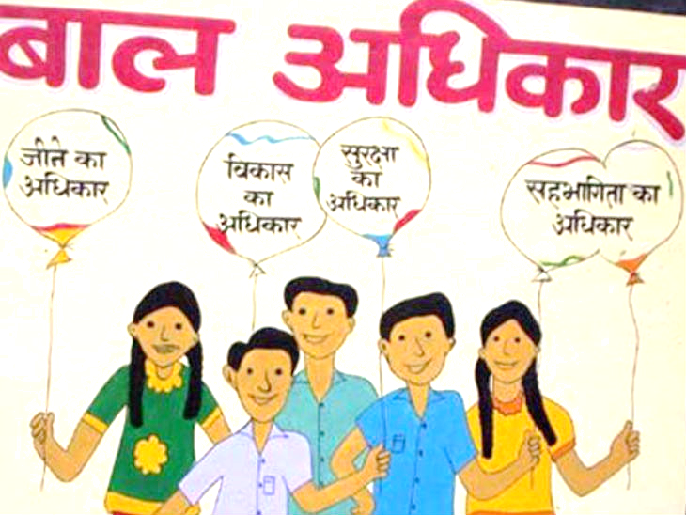@prayas_jac
@prayas-jac-society


 @PrayasJACSociety @prayas_jac
Prayas JAC Society
59, Tughlakabad Institutional Area, New Delhi 110062 Email: prayas@prayaschildren.org www.prayaschildremn.org

